Comparison of Net-Zero Initiatives
Climate Change Centre Austria
Horak Peter

Contents
1. Introduction 4
1.1 How to use the comparison document(s) 4
1.2 Overview of introduced categories. 4
1.3 Categorization of analyzed initiatives 5
1.4 Connectivity of chosen initiatives 5
1.5 Comparison with other assessments 6
1.5.1 Oxford Net Zero 6
1.5.2 Pathways to Paris 7
1.5.3 UN high level experts’ group 7
1.5.4 NatCen 7
2. End state targets defined by science / industry guidelines 8
2.1 End state definitions by science (IPCC) 8
2.2 End state targets defined by industry guidelines (carbon neutral and net zero) 9
2.3 Definition of “Science-based” 11
3. Applied net-zero terminology 11
3.1 End states as used in the industry with focus on DACH 11
3.1.2 Application in Politics 11
3.1.1 Application in the Industry 13
3.2 Specificity of end state announcements 17
4. Scientific background 18
4.1 Intergovernmental Panel on Climate Change (IPCC) 18
4.1.1 Background and purpose 18
Key takeaways regarding the IPCC 19
4.2 International Energy Agency (IEA) 19
4.3 Comparison of IEA and IPCC scenarios 20
4.4 Oxford Net Zero Principles 21
5. Measurement 23
5.1 GHG Protocol 23
5.1.1 Background 23
5.1.2 Description 23
Scope 1 23
Scope 2 24
Scope 3 24
5.1.3 Key takeaways regarding the GHG Protocol 24
5.2 International Organization for Standardization (ISO) 25
5.2.1 Background 25
5.2.2 Description 25
5.2.3 Key takeaways regarding the ISO Reporting documents 25
5.3 Comparison ISO and GHG Protocol 25
6. Target setting 26
6.1 Origin of comparison criteria 26
6.2 Criteria for comparison of target setting 26
6.2.1 Overview (Step-by-Step Process) 26
6.2.2 Suitability 26
6.2.3 Quantification and Reporting 26
6.2.4 System Threshold 26
6.2.5 Offsetting 26
6.2.6 Targets/Methods 27
6.2.7 Sector specificity 27
6.2.8 Intermediate Targets 27
6.2.9 End state Target 27
6.3 Science Based Targets initiative (SBTi) 27
6.3.1 Background 27
6.3.2 Comparison outcome 28
6.3.3 SBTi as arguably the standard with the highest reputation when it comes to target setting 29
6.4 ISO/CD 14068:2022 31
6.4.1 Background 31
6.4.2 Description 31
Comparison outcomes 32
6.5 Race To Zero 32
6.5.1 Background 32
6.5.2 Comparison outcomes 33
6.5.3 Race to Zero and SBTi 33
6.6 2030 Breakthroughs 34
6.6.1 Background 34
6.6.2 Comparison outcome 34
6.6.3 6.6.3 Sectoral approaches of SBTi and Breakthrough 2030 34
6.7 IWA 42 34
6.7.1 Background 34
6.7.2 Comparison outcomes 35
6.8 Umweltbundesamt DE 35
6.8.1 Background 35
6.8.2 Comparison outcomes 35
6.9 PAS 2060 35
6.9.1 Background 35
6.9.2 Comparison outcomes 35
7. Offsetting 37
7.1 The Oxford Offsetting principles 37
7.1.1 Background 37
7.1.2 Description 37
8. Reporting 38
8.1 CDP (formerly Carbon Disclosure Project) 38
8.1.1 Background 38
8.1.2 Description 38
8.2 European Sustainability Reporting Standard (ESRS) 38
8.2.1 Background 38
8.2.2 Comparison outcome 38
8.2.3 ESRS and CDP 39
9. Net zero guidance comparison 40
9.1 Overview (Step-by-Step Process) 40
9.2 Suitability 40
9.3 Quantification and Reporting 41
9.4 System Threshold 41
9.5 Offsetting 42
9.6 Targets/Methods 42
9.7 Sector specificity 43
9.8 Intermediate Targets 43
9.9 End state Target 43
10. Conclusion 45
11. References 46

Introduction

How to use the comparison document(s)
This document shall be used in combination with the provided excel framework from which much of the information that is presented in this document is drawn from. In the corresponding excel, the exact formulations of the respective standards/initiatives as well as the simplifications that have been made to draw conclusions are available in a comprehensible manner. This is important due to the nature of this comparison, where oftentimes complex or ambiguous sentences and concepts are broken down to their core structure. To do so, for rather vague definitions and descriptions, a decision regarding their interpretation must be made inevitably. To make this approach transparent and enable the possibility of retroactively changing or challenging some interpretations, the information has been provided in this format.
In general, this document provides the results in an accumulated form, drawing conclusions and interpretations from the information of all standards and initiatives that were assessed. Furthermore, it tries to provide insights that exceed the mere content of the respective standards and instead strives to highlight interconnections that are not apparent when simply reading the respective documents.
For insights on a more detailed level (as in initiative to initiative) the information is provided in the excel. This information is not repeated in this document unless it provides insights that are relevant to draw high-level conclusions to avoid redundancy.

Overview of introduced categories.
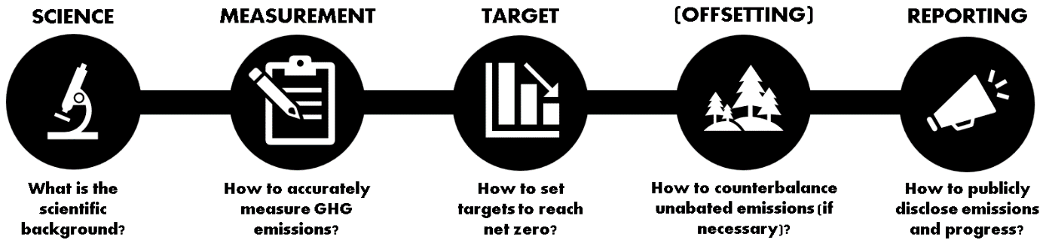

Figure 1: Overview of categorizations
In the recent decades, there have been a lot of different initiatives that were created with the intent of delivering much needed clarity and guidance on different aspects of sustainability. While those initiatives often have common general ideas, they vary in their specific requirements and recommendations. The focus of this document is to provide a comparison on some of the most important net-zero initiatives for the industry, product, and cities.
To systematically approach this comparison, the initiatives shall be split into distinct categories in regards to their main focus areas – roughly based on the differentiation system introduced by Oxford Net Zero (Mcgivern et al., 2022), as displayed in Figure 1. While some guidelines have a broader focus that exceeds one area, they have been categorized none the less by their main focus area (Mcgivern et al., 2022). In this document, the categorizations provided by Oxford Net Zero have been adopted whenever possible. Documents that were not covered in Oxford Net Zero’s comparison (or exceed the listed categories) were categorized based on the perceived focus of the document at hand. The only category that has been newly introduced in this comparison document is the “Science” category, to establish an understanding of the scientific consensus on climate change and especially potential future scenarios.

Categorization of analyzed initiatives
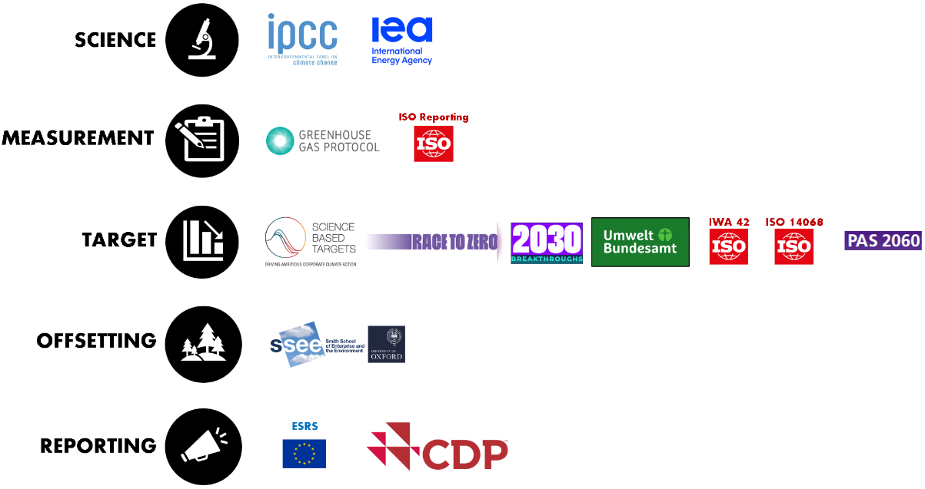
Figure 2: Categorization of analyzed initiatives and documents
While the idea of a “one-size-fits-all” solution for sustainability might be an attractive concept in theory, the reality of the net zero initiatives landscape looks very differently. Depending on the area an entity wants to cover, different initiatives can be chosen from. While some initiatives cover more than one of the areas, they do so with varying specificity and requirements.
For this document, the categories that are displayed in Figure 2 are analyzed. Neither the categories that are used here, nor the initiatives and documents within these categories are exhaustive, nor is the comparison of any other initiative that is mentioned in this document. However, they contain some of the most important initiatives in their respective areas and as such shall be used to draw an overall impression.

Connectivity of chosen initiatives
As shown in Figure 3, the different initiatives and standards are highly interconnected. The connections that are drawn here are limited to directly neighboring categories (otherwise it is fair to say that most initiatives listed here would refer either directly or indirectly to the SBTi for example). The only exceptions to this rule are Race to Zero and Breakthrough 2030, as those directly build upon each other, and at least Breakthrough 2030 necessitates the guidance of Race to Zero.
What can be shown here is that the decision regarding which measurement document an entity builds its measurement methodology on is already a soft commitment regarding a possible path forward. As demonstrated, most target setting initiatives are built on (or recommend, shown as dashed lines) either one or the other of the two reporting documents.
While ISO 14068 offers a translation table for the GHG protocol towards the ISO reporting documents (described in subsequent sections), this still requires additional resources and a potential adaptation of an entity’s current reporting process.
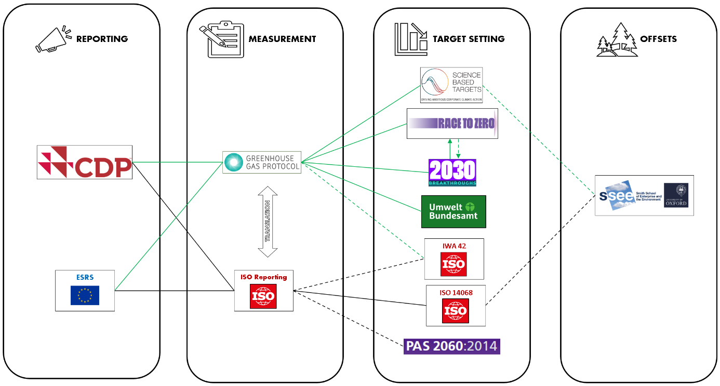

Figure 3: Connection between initiatives and guidelines in different categories

Furthermore, what can be seen here, is that there is no “one size fits all” document or initiative that fully outlines the way towards net zero on its own. A multitude of different documents and their guidance will be necessary to adequately consider each area and set respective boundaries.

Comparison with other assessments
As previously mentioned, the described list of initiatives is nowhere near exhaustive. With that in mind, the results provided from this assessment can only be seen as a sample size for the entire net zero landscape. However, as some of the arguably most important initiatives were purposely chosen for this comparison, it can be argued that this the accumulated initiatives are not a very representative sample as the initiatives that are chosen here most often could be categorized as “Pace – Setters” in at least some aspects of their categories (a Pace-Setters is what Oxford Net Zero describes initiatives or practices that are leading or pioneering in their respective areas).
Therefore, to put the results into reference, four different documents / initiatives shall be used to compare the results and put them into perspective. For the comparisons of Oxford Net Zero and Pathway to Paris it shall be mentioned that since they draw comparisons across initiatives from multiple different categories, the percentages for certain aspects that are compared in this document are comparably lower than perhaps the results of this comparison. One of the reasons for that is that results of all categories were considered for these comparisons, however, some documents simply do not cover certain areas. For example, the GHG protocol does not specify when an entity must reach net zero because this is not a focus area of reporting documents in general. However, the comparison still provides valuable perspective regarding the results of this comparison.

Oxford Net Zero
Oxford Net Zero (will be occasionally abbreviated with ONZ in this document) is an interdisciplinary research initiative based in the University of Oxford’s fifteen years of research on climate neutrality.
In their comparison of the net zero landscape, a total of 33 different sustainability initiatives were analyzed on a variety of parameters (Mcgivern et al., 2022).

Pathways to Paris
Pathway to Paris is a collaboration between the WWF (a leading wildlife conservation organization) and PwC (one of the “big 4” accounting firms) (Pathway to Paris, n.d.). In their online tool, they compare a total of 22 different initiatives and standards on various metrics.

UN high level experts’ group
In their report, the expert group is called “the United Nation’s high level expert group on the net zero emissions commitments of non-state entities “– for simplicity reason the group shall be called the “UN expert group” in this document for the most part. The purpose of the group is described in the document as follows:
“The High-Level Expert Group on the Net Zero Emissions Commitments of Non-State Entities (“Expert Group”) was tasked by the United Nations Secretary General with addressing net zero pledges and commitments from non-state actors including corporations, financial institutions, and local and regional governments. In undertaking its work, the Expert Group built on existing credibility and standard setting frameworks for net zero pledges to formulate its findings and recommendations” (United Nations, 2022).

NatCen
NatCen describes themselves as “Britain’s largest independent social research organization” (NatCen, 2022). The research organization published a net zero comparison document containing “an extensive literature review and qualitative in-depth interviews with a broad range of stakeholders.”, that was prepared for “Our 2050 World” with funding by BSI (NatCen, 2022). In this document, this paper shall be primarily used to gain some qualitative insights in connection to the findings of this comparison.

End state targets defined by science / industry guidelines

End state definitions by science (IPCC)
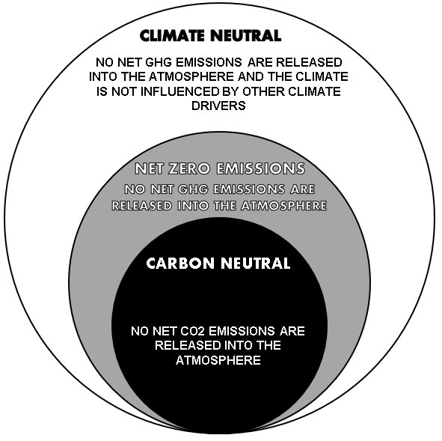

Figure 4: End state definitions as defined by IPCC

Achievable “end states” as shown in Figure 4 are defined by the IPCC on a global scale – meaning underlying concept is achieved for the entire globe. Essentially, each concept builds upon the previous definition and adds further aspects. Carbon neutral is used synonymously with net-zero-CO₂ (IPCC, 2021).
While leading net zero initiatives such as SBTi (SBTi, 2021) and Race to Zero (Race to Zero, 2022) are building their definitions upon those defined by the IPCC, this is not the case for all standards and certainly not in the industry or politics. In practice, the terminologies and concepts for achievable end states are used pretty inconsistently when they are applied (New Climate Institute & Data-Driven EnviroLab, 2020).

2.2 End state targets defined by industry guidelines (carbon neutral and net zero)

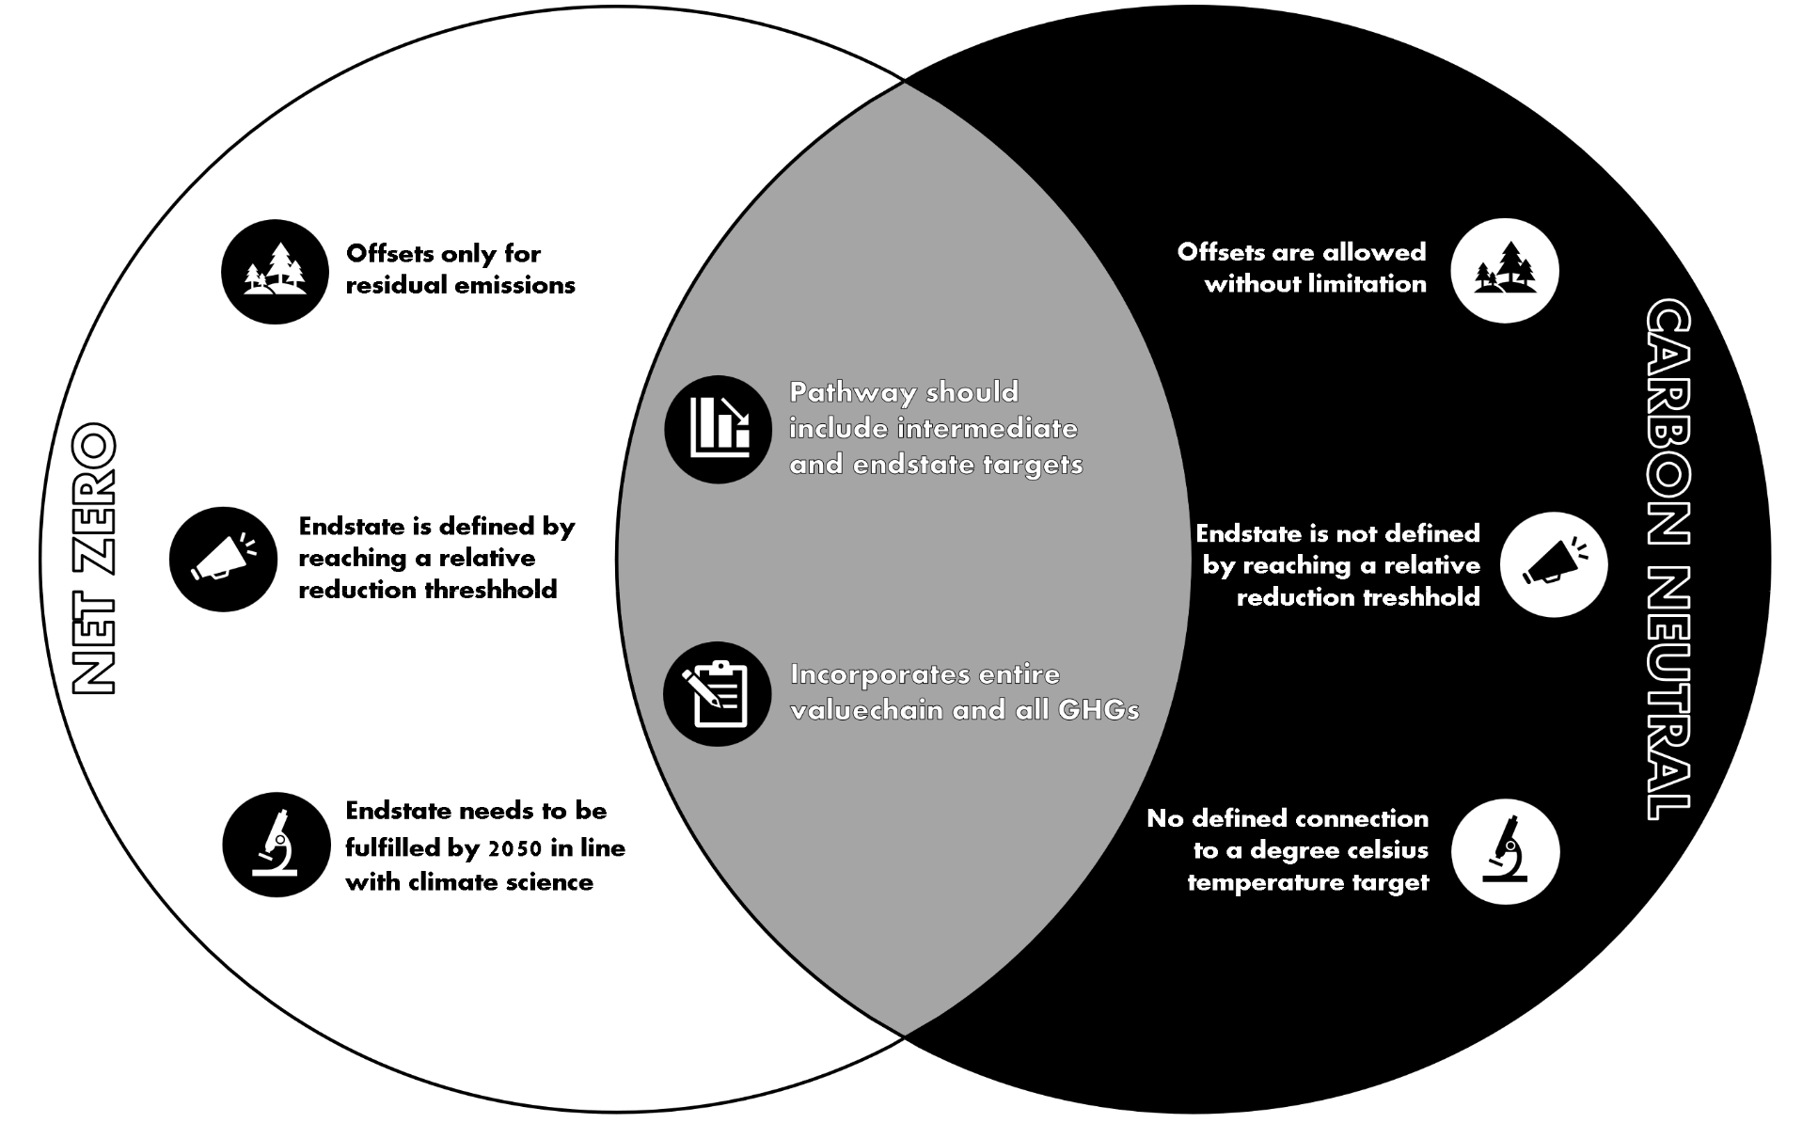
Figure 5: Comparison of the concepts “net zero” and “carbon neutral”
As Figure 5 indicates, the concepts of “carbon neutral” and “net zero” are different in a variety of ways. The derived concepts in the graph have been summarized and simplified from the assessed standards.
Net zero largely represents the SBTi version of the term (with high similarity for the other standards regarding the fundamental concepts), while carbon neutral is based on the ISO 14068 and PAS 2060 definition. Both concepts focus on no net emission of any GHGs (carbon referencing all GHGs in that sense), the differentiation lies in what this actually entails.
The first key difference can be found when analyzing the respective roles of offsetting. Here, carbon neutrality allows essentially unlimited offsetting (regarding the amount of emission that can be offset), which in theory enables an entity to become carbon neutral without any emission reduction. While the standards are still highlighting the importance of emission reduction and the inclusion of a final abatement goal, they do not specify what that means numerically. While these standards allow the implementation of offsets without limitation, they also have the strictest requirements for these offsets out of all the standards assessed based on the criteria chosen for this comparison.
Net zero limits offsetting to their defined residual emissions, which must be reached without any offsetting by emission reduction alone.
Apart from that, carbon neutrality does not necessitate an alignment to any degree Celsius scenario.
While those two endstates could be interpreted as alternative end states, this does not have to be the case necessarily. Neither PAS 2060 nor ISO 14068 claim that once carbon neutrality is reached the decarbonization journey ends, on the contrary, they highlight the importance of reducing emissions over time. However, both standards don’t get specific regarding what comes next once carbon neutrality is reached.
A sentiment that was expressed both in literature and in Nat Cen’s qualitative assessment was the idea of combining both concepts. Essentially, carbon neutrality can be viewed as the pathway towards net zero, which is also in line with the standards that govern carbon neutrality. While they do not get specific regarding timeline or numerical information, the carbon neutrality standards still highlight the importance of emission reduction over time. NatCen summarizes this viewpoint as “carbon neutrality is an intermediate recurring goal ensuring that corporate efforts are consistent with the achievement of the global Net Zero goal” (NatCen, 2022).
However, while on the surface the simultaneous implementation of both concepts combined may seem like a good fit both conceptually and from an environmental perspective, the practicality of these two concepts combined raises some questions as well.
Firstly, “carbon neutrality” builds upon ISO reporting and net zero primarily on the GHG protocol, meaning to implement reporting that satisfies both concepts would mean additional work. NatCen has highlighted the perceived complexity of ISO as a standalone initiative in their stakeholder assessment, this complexity would not be reduced when adding another set of requirements (the GHG protocol) with sometimes different terminologies and concepts on top.
Secondly, even if the issues regarding the credibility of offsets are ignored, according to NatCen there are simply not enough offsets around for this to be a scalable solution for the entire industry sector (NatCen, 2022).
However, companies could simply be inspired by the concept without necessarily taking the step of verification by the standards they don’t currently report on. The benefits of so called “Beyond value chain mitigation” is highlighted by SBTi multiple times (even though it cannot be used for emission reduction until residual emissions are reached), therefore, the combination of both concepts could be viewed as a “Pace-Setter” principle (SBTi, 2021).
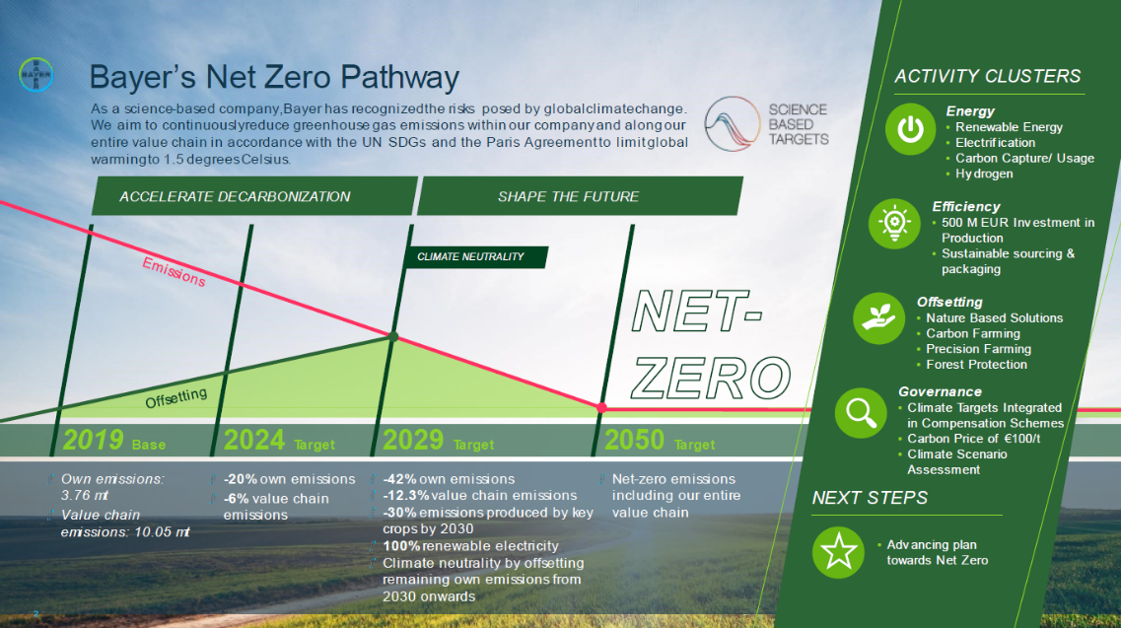
The fact that this approach is possible is demonstrated by Bayer’s net zero pathway (Bayer, n.d.-a), as shown in Figure 6.

Figure 6: Bayer's Net Zero Pathway (Bayer, n.d.-a)

2.3 Definition of “Science-based”
Out of the standards that define “science-based”, 83% (5/6) state it is connected to the main objective of the Paris Agreement. Race to Zero goes as far as to say the two can be used interchangeably (Race To Zero, n.d.). Specifically, Paris-aligned references the following section of Article 2 of the Paris Agreement (Delbeke et al., 2019):

“This Agreement, in enhancing the implementation of the Convention, including its objective, aims to strengthen the global response to the threat of climate change, in the context of sustainable development and efforts to eradicate poverty, including by:
- Holding the increase in the global average temperature to well below 2°C above pre-industrial levels and pursuing efforts to limit the temperature increase to 1.5°C above pre-industrial levels, recognizing that this would significantly reduce the risks and impacts of climate change”

Therefore, it can be concluded that for the standards that define and necessitate science-based actions, this means to limit the global average temperature increase to well below 2°C or ideally 1.5°C. While this gives orientation, the complexity results from trying to break down what this ambition level entails regarding concrete, measurable actions on an entity-to-entity basis.

Applied net-zero terminology

End states as used in the industry with focus on DACH

Application in Politics
A rather illustrative example of the problematic nature of the term “klimaneutral” is provided in an article of the European parliament titled “Was versteht man unter Klimaneutralität” or in the English version “What is carbon neutrality”. While this already demonstrates the first problem, which is that the translation of the word changes the term of interest from one established concept to another (carbon neutrality to climate neutrality), this shall be ignored for the moment as it is not the primary issue in this article.
What is demonstrated here is essentially the way “Klimaneutralität” is used in the political context. What is described as “climate neutrality” in this article describes the concept defined as “net zero emissions” according to IPCC, but for the moment, it shall be argued that this is due to different terminologies that are used depending on the scale of reference (political or state level in comparison to global). The article describes “Klimaneutralität” as net-zero-CO2 emissions, clearly differentiating it from “net-zero-emissions” that would entail all emissions as highlighted by the article (which makes the theory that the article is talking about so called “CO2e” rather unlikely). In the very same article however the article connects the term “Klimaneutralität” to the European Green Deal. The content of this “Green Deal” is to “[…] no net emissions of greenhouse gases by 2050” (European Commission, n.d.-b).
In effect, what the article does here is it relates the word “Klimaneutralität” to two different concepts of the IPCC. To explain in more detail: first, the term is described as net-zero-CO2 emissions or carbon neutrality (by IPCC’s definition) and secondly net-zero-GHG-emissions or net-zero. While the differentiation is also rather vague in the very same English-written article, at least it exists by the usage of carbon neutrality and climate neutrality. By translating the article, this differentiation simply disappears – essentially merging two distinct concepts into one.
Essentially, the article that is (somewhat ironically) titled “what is Klimaneutralität” answers the question as follows: the emission reduction of an entity’s CO₂ emissions or roughly 79% of it’s entire emissions (average CO₂ content of anthropogenic emissions (EPA, n.d.)) or all GHGs which makes up for 100% of an entity’s emissions.
There are two possible interpretations regarding the causality of this issue: this is either a mistake or simply the problematic nature of this term on display.
If it is in fact a mistake, then this essentially means that not even the European Parliament can clearly determine when and how to use the term “klimaneutral”. If this is simply the nature of the term and not a mistake, then it is even more problematic, as it means the terminus is essentially undefined and can be used interchangeably for two very separate concepts.
This showcases the difficulty of terminology in the political context, especially when different languages than the original one – English – are introduced. The German article displays that the term “klimaneutral” is not clearly attributable to a single concept, as it simply unites the clearly distinguished concepts from the English article into one word.
It could be argued that this necessitates further definition of the term “Klimaneutralität”, however, who would define this term “klimaneutral”? Arguably it is not science, because it is not the IPCC’s definition that is being used here.
How about international standards? Currently, there is the possibility to certify “Klimaneutralität” by the TÜV – based on the PAS 2060 standard that is analyzed in this document. As previously described, PAS 2060 governs the concept of “carbon neutrality”, which the initiative translated to “klimaneutral” – analogously to the article of the European Parliament if only the word for word translations are considered. However, the problem is that this “carbon neutrality” is not the IPCC’s version of carbon neutral as described in the article by the European parliament. Instead, to highly simplify the PAS 2060 version of carbon neutrality, it is essentially “net zero with no carbon offset limitations”.
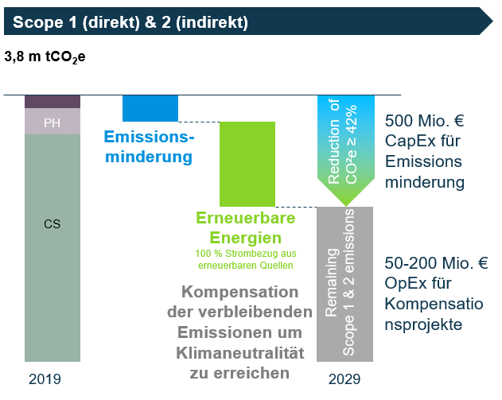

Figure 7: “Klimaneutralität” as used by Bayer (Bayer, n.d.-b)
The connection of “Klimaneutralität” to the concept is already being applied by some actors (in the industry) such as Bayer (Bayer, n.d.-b). To put the information that is provided into context, Bayer describes that it will reach “Klimaneutralität” by incorporating:
- Scopes: Scope 1 and 2
- Ambition: 1.5°C
- Role of Offsets: over 50% of the base year’s emissions
To summarize all the above, it seems like a fair assessment that the terminology used for end state targets is not very conclusive regarding what concepts it actually entails.

Application in the Industry
In the English language, most commonly the two words “net zero” and “carbon neutral” (IPCC’s version) are being used, with some announcements also using “climate neutrality”. According to NatCen, the usage of net zero is seeing increased popularity in regards to usage (NatCen, 2022).
It shall be noted that in this document there was no extensive comparison of a representative amount of industrial end state targets executed, however, the conclusions shall pose as indicators regarding what is currently done in the industry. Simplified, the current usage of the terminology could be described as visualized in Figure 8.
The concepts companies refer to when talking about “klimaneutral” can take various forms. For example, when looking at the example of Bayer, the company has a SBTi approved net zero target for the long run – which is also how describes its target (in German and in English). In the short run, it has few intermediate targets for different areas which would (and in fact do for the English version of the article) translate to “carbon neutrality” while others are still called “climate neutral”(Bayer, n.d.-b).

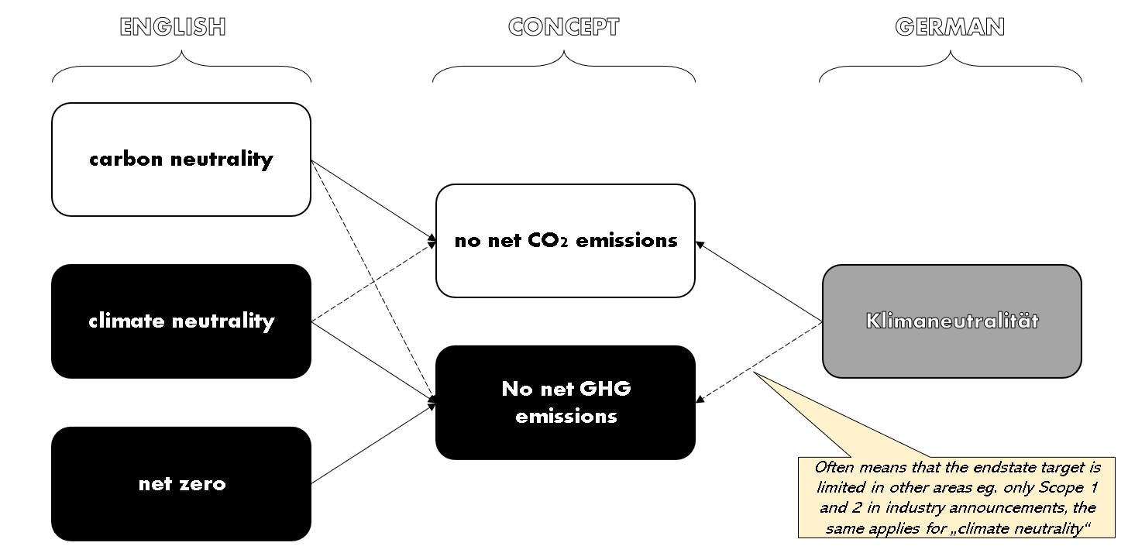

Figure 8: simplified comparison of perceived industry usage of end state terminology
Oftentimes targets are described as “climate neutral” if those are harder to define with more established terms. Since the term is ambiguous and not consistently defined by anyone (besides IPCC, but their definition of climate neutrality is not commonly used as it exceeds the ambition of) at this date, it seems to be flexible in its interpretation and usage. Magna (Magna, n.d.) and Dow (Dow, n.d.) also use “klimaneutral” in order to describe their carbon neutrality (IPCC) targets. However, when translated to English, those terms change to “carbon neutrality”. While this then also needs differentiation regarding IPCC or PAS 2060, it at least limits the scope of possibility somewhat.
Lanxess has set themselves the target of becoming “climate neutral” by 2040. The target is SBTi approved, and specifically highlights in the article that all greenhouse gases are included, to the contrast of Magna or Dow (Lanxess, n.d.-b). As someone who is not familiar with the topic, the level of ambition of Lanxess relative to that of the other described examples may seem like a disservice to Lanxess, as the company is not only aiming for a more ambitious involvement of greenhouse gases but also include other specifics as required by SBTi.
Or at least that is how it may seem at first glance. When investigating further, the entire article does not mention the term “scope” once, which could be interpreted as a coincidence. However, as the firm has an SBTi target that requires them to only communicate in a very specific manner about their end state targets (SBTi, 2021), the more experienced reader may continue researching further. And indeed, the company has another published article stating that their entire value chain will become “climate-neutral” (by 2050). In this article, the firm has apparently rediscovered their ability to differentiate emissions into scopes and describes in detail their “net zero value chain” initiative from a scopes perspective as well (Lanxess, n.d.-a). To the firm’s credit, in their first article they mention in one sentence that it is about the corporate’s “own emissions”. Yet, it defines both states as “klimaneutral” or “climate neutral” and therefor to some extend equals SBTi’s net zero approach with “klimaneutral” – which does not reflect the ambition that companies like Dow or Magna are currently pursuing under the same terminus. Looking at the previously introduced graph (Figure 7) that shows Bayer’s implementation of “climate neutrality” essentially equals carbon neutrality as introduced by PAS 2060 or ISO 14068, so yet another concept.
While this is not an attempt to suggest Magna or Dow are intentionally using the ambiguity of the term for greenwashing purposes, it still demonstrates how the term is very unspecific at a very fundamental level already (in terms of what greenhouse gas emissions, scopes or concepts are used). This problem is not limited to companies with lower levels of ambition, as it could be argued that especially Bayer and Lanxess have rather ambitious climate targets.
While this shows that the problem is not limited to the German language, from the examples assessed so far, the English language at least offers the differentiation between net zero and carbon neutrality that in the German language does not seem to exist (on a conceptual level).
This poses the question what kind of information an end state term isolated from any further specification can transfer in regard to an entity’s emission target. Arguably, the only information that can be provided in this fashion is the greenhouse gas involvement level. For example, “Netto-Null-CO2-Emissionen” is used to describe a goal that is limited to CO₂ emissions. As described earlier, the complexity of carbon neutrality and net zero within the industry exceeds the simple inclusion or exclusion of certain greenhouse gases as defined by the IPCC, however, the term “klimaneutral” is not equipped to deal with those nuances as it cannot possibly differentiate two (or more) different concepts within the same term. Currently, as visualized in Figure 9, the term is used for four out of five of the concepts introduced in this document, not including instances where the usage of the term does not match any predefined term (for example, Figure 7 shows Bayer’s approach which is technically not aligned with any of the introduced concepts as it is limited to scope 1 and 2).
This means in conclusion that the most of these terms are – if they are isolated – rather unspecific and relatively meaningless unless further specification is given. “Klimaneutralität” suffers from this arguably more than the other established terms, because apart from translational inconsistency, the terminus is currently not defined in any perceivable way.
The sentiment that ambiguity can be exploited for “greenwashing” and questionable claims was also highlighted in NatCen’s assessment (NatCen, 2022). To relate this back to the previously introduced terminology – what does this mean regarding possible applications for “klimaneutral” in end states? The answer is simple. Conceptually the term is essentially interchangeably used for all concepts except for “climate neutral” by IPCC, which is ironic considering that climate neutrality is be the literal translation of the term.

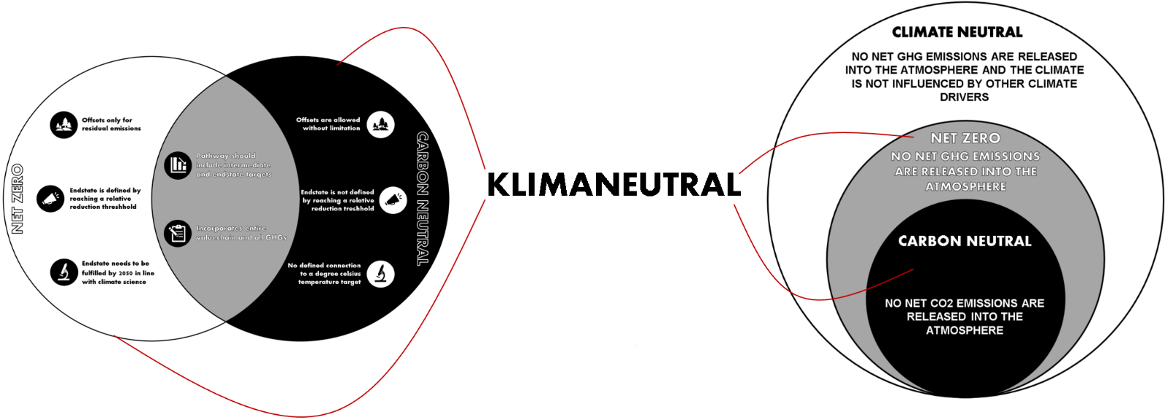

Figure 9: Visualization of "Klimaneutral" usage based on perceived usage
However, there are attempts to overcome this issue. The German environmental agency calls their guidance “der Weg zur treibhausgasneutralen Verwaltung“. The English version? „The path to greenhouse gas neutral administration” – which is basically a word for word translation of the original title. It is clear, precise, and easily translatable. Furthermore, it is not in direct contradiction with the leading documents on climate science regarding its definition of the end state that is to be acquired and is therefore in line with what leading industry initiatives such as SBTi and Race to Zero and therefor and perhaps more importantly the IPCC’s original definition of the terminus.
There are also plenty of corporate examples of where clear and precise terminology is chosen, such as BASF’s climate ambition announcement (BASF, n.d.). In the entire article, the corporation does not use the term “klimaneutral” once, instead they use clearly defined terminology such as “netto-null Emission” or in English “net-zero emissions”, in line with the IPCC. When they only refer to CO₂, they also specify that (net-zero-CO₂ or netto-null-CO₂), without hiding behind the ambiguity of terms like “Klimaneutralität” as a one-term-fits-all solution. The chosen nomenclature is clear, precise, and as much information as this term can possibly include (how much greenhouse gas emissions does an entity want to reduce). For everything beyond the emission level, further specification or a reference to an industry standard is inevitably needed anyways (Figure 10).
Within sustainability, the importance of terminologies has been highlighted repeatedly, displayed for example by the transition away from terms such as “global warming” to “climate change” and finally (for the moment) “climate emergency” or “climate disaster”. Consistency and transparency are important to enable the conversation about topics that need clarity not because of their inconsistent usage, but rather because there is no consensus yet on how to define and benchmark them. Those issues include but are not limited to the definition of residual emissions, pathway towards net zero and role of offsetting.
For example, the word “greenhouse gas effect” has often been described to be an unfortunate choice of words, as the underlying physical effect is not quite the same as that of an actual greenhouse (as in physically trapping the gas which cannot escape). However, the term is globally understood and established – and therefor it is possible to discuss concepts involving it. That does not mean the term is perfect by any means, but arguably perfection is less important than consistency of usage to create transparency and clarity around a concept.
The real problem here is, if not even the high-level nomenclature and definitions are aligned, it makes the real discussion unnecessarily harder. The basic sentiment that climate change is a global phenomenon and needs a global effort is at this point pretty much universally established. The latest demonstration of this is the currently discussed carbon tax law, that would impose tariffs on imports from countries that fail to take steps to their greenhouse gas emissions (The New York Times, 2023).
To follow their environmental responsibility, countries, cities and companies will have to be held accountable, both by each other and by the public. For that to be remotely in the realm of possibilities, it needs clearly defined concepts and terminology – and consistent usage of those terms. It cannot be expected from an average citizen to be able to differentiate by referenced system (planet, country, city or corporate), terminology of the chosen sustainability initiative (if any is chosen at all) and finally arbitrarily chosen regional terminologies such as “Klimaneutralität”. If every country, state, or city would decide to introduce their own meaning and concepts to randomly assigned words in the context of sustainability and certify them on a regional level, global comparability would become next to impossible. Therefore, it may seem questionable if terms such as “Klimaneutralität” should be promoted for mainstream usage for concepts similar to SBTi’s net-zero.
While the argument could be made that terms such as “Klimaneutralität” are established regionally, the counter argument would be the increase of globalism and therefor rise of the importance of the English language. As such, while the importance of such terms may stay the same or increase in the regional language, the relative importance of the English language increases. The usage of uniform terminology is of course especially important in the context of trans-cultural, global problems such as climate change.
The white house has chosen an interesting path in this regard in one of their more recent announcements, proposing a plan for the federal supply chain to report their emissions to CDP and set targets with SBTi (The White House, 2022). By doing so, President Biden is essentially choosing two of the most well renowned and highly regarded standards for their environmental disclosures and target setting (indirectly three since SBTi is built on the GHG protocol). What that could do is to level the playing field, increase comparability and transparency by choosing two of the initiatives with arguably the highest standing and reputation in their respective fields.
This sentiment is also something that is echoed from within the industry, where a statement of one of the industry stakeholders assessed by NatCen reads as follows (NatCen, 2022):
“If you don't have a commonly accepted framework, then how do you know that the benefits are being realized? How do you compare yourself across the globe to make sure that you are reporting on actual progress? I think […] having a multitude of systems creates a lot of disruption. It could lead to delay, it could lead to inefficiencies… Just having common systems, common language, common metrics I think would be critical for a global effort towards climate change.”

Specificity of end state announcements
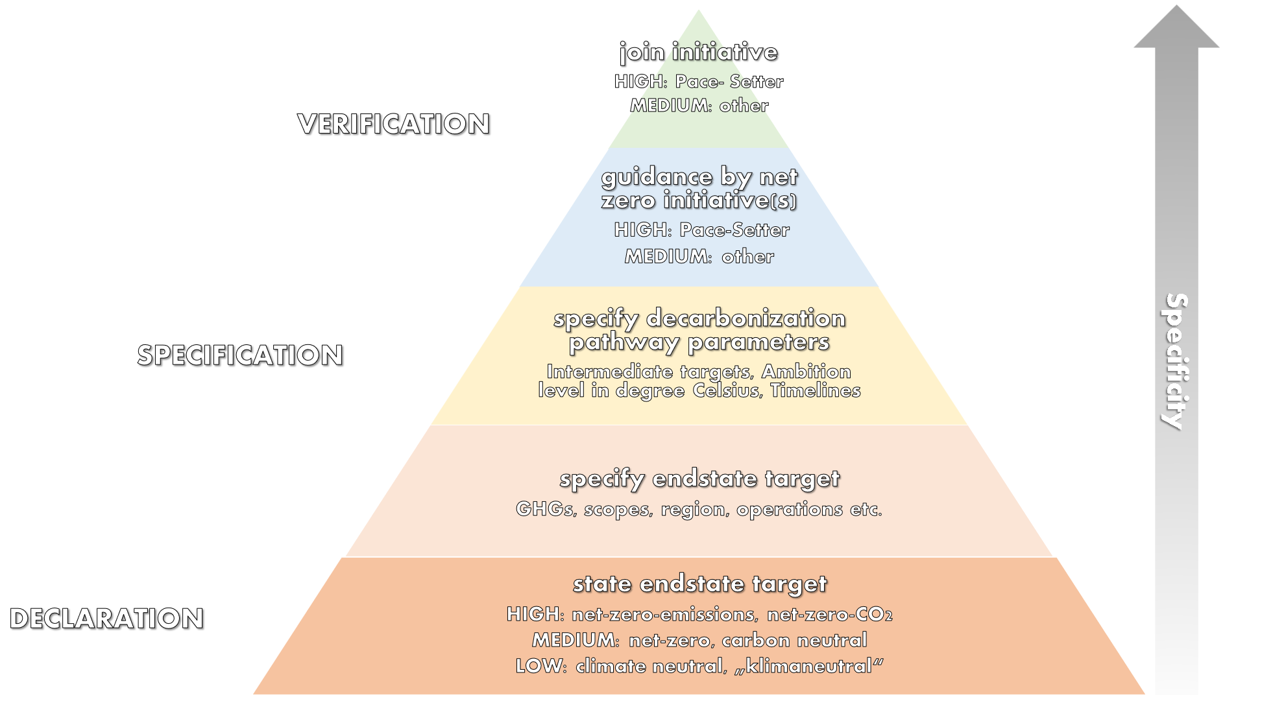
Figure 10: Specificity pyramid concept based on perceived specificity of end state targets
As previously described, the announcement of an end state target alone does not necessarily mean it is clear which concept it describes, since now the usage of those terms is rather inconsistent. To increase the transparency regarding end state targets, it is therefore necessary to specify certain parameters such as the scopes and emissions that the chosen end state entails.
From there, while the end state is somewhat defined, both the pathway to the end state as well as the end state itself have still a lot of uncertainties involved regarding issues such as residual emissions and the role offsets can play. Therefore, to further increase the specificity of a chosen end state, it makes sense to reference the initiative the respective decarbonization boundaries are derived from. Here, as will be demonstrated, it makes a difference which initiative is chosen, as pacesetters have a higher level of specificity in regards to the requirements and therefor in turn also increase the specificity of the end state that is targeted or announced.
To illustrate this, Figure 10 displays the level of specificity that comes with the usage of the word. While this is of course not an exhaustive system, it could still provide an initial idea towards the relative value and transparency of end state targets.

Scientific background
This category entails initiatives that are often referred to when it comes to the scientific reasoning when it comes to certain specifics on how to reach net-zero. As many of the reviewed standards have the requirement for anyone behaving according to their defined principles to be “science-based”, those are often timing the sources that are referred to.

Intergovernmental Panel on Climate Change (IPCC)
    - Background and purpose
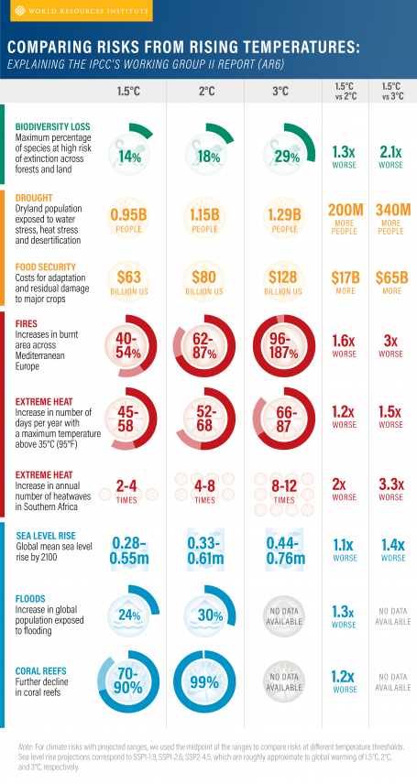
The IPCC was originally founded in the year 1988 by the United Nations Environment Program (UN Environment) and the World Meteorological Organization. The purpose was to “provide policymakers with regular scientific assessments on climate change, its implications and potential future risks, as well as to put forward adaptation and mitigation options (WMO)” (IPCC, n.d.).
To do so, it examines the available scientific literature and publishes the findings in so called “Assessment Reports”. This means the IPCC does not carry out its own research, but rather draws conclusions from available scientific research.
Especially relevant in the context of this report are the IPCC’s so called emission scenarios. In their Special Report of the year 2000, the IPCC defined a scenario as follows: “Scenarios are alternative images of how the future might unfold and are an appropriate tool with which to analyze how driving forces may influence future emission outcomes and to assess the associated uncertainties” (IPCC, 2000). Several of such scenarios have since been created and updated in subsequent assessment based on improved methodologies and insights.
Figure 11: Comparing Risks from rising Temperatures (WRI, 2022)
To understand those scenarios, the concept of a carbon budget is of great importance, which in the words of IPCC means the following: “the estimated cumulative amount of global carbon dioxide emissions that that is estimated to limit global surface temperature to a given level above a reference period.” (IPCC, 2022b). This means, based on cumulative anthropogenic carbon dioxide emissions different scenarios, their effect on the world’s global average surface temperature is evaluated and the likelihood of resulting consequences assessed. In total, the IPCC has identified over 200 scenarios that are consistent with either 1.5°C or 2°C warming (Fankhauser et al., 2022).
To put this into perspective, one of the IPCC’s current estimates regarding the remaining carbon budget (referring to CO₂ that can be emitted) is 500 GtCO₂ for a 50% probability of 1.5°C. In comparison, to limit global warming to 2°C with a 67% probability the emit able carbon would be 1150 GtCO₂ (IPCC, 2022a). The consequences temperature increases could have are displayed in Figure 11, which contains a summarization of the potential risks that were assessed by the AR6 working group II (WRI, 2022).
Key takeaways regarding the IPCC
- Assessment of status quo of climate science
- IPCC assesses what the depletion of a defined carbon budget (as in tones of CO₂ to be emitted) would lead to regarding temperature increase by 2100 (with a certain probability)
- Net zero guidelines often referred to these scenarios and their correlated temperature increases as well as probabilities to define the level of ambition of their guideline

International Energy Agency (IEA)
The International Energy Agency, or short IEA, was created in 1974 as a response to the 1973-1974 oil crises, that industrialized countries didn’t feel adequately equipped to deal with. Its purpose was to pose as the main international forum for energy cooperation on a variety of different energy related issues. Even though energy security is still one of the defining issues the IEA deals with, in the last decade the scope of the organization has evolved due to the necessary adaption of the global energy system. As a result, the global transition towards green energy gained importance as an issue for the IEA (IEA, n.d.).
Similarly, to what was the described earlier for the IPCC, the IEA also analyses scenarios, with a focus on the energy sector and from the energy perspective.
In 2014, the IEA released their flagship report “Energy Technology Perspectives 2014”, in which it analyzed three different possible energy futures for 2050 based on average temperature increase (2°C, 4°C and 6°C) (International Energy Agency, 2014). The 2°C variant, also called 2DS, is what the SBTi initially build their Sectoral Decarbonization Approach on (SBTi, 2015).
In October 2020, the “Net Zero by 2050 – A Roadmap for the Global Energy Sector”, which as the name suggest includes global pathways towards net-zero emissions was released. In it, the IEA outlines pathways to reach net zero emissions by 2050 (IEA, 2021).
The WRI describes five takeaways from the IEA’s document:
- Annual renewable electricity installations must triple by 2030
- Fossil fuel phaseout is inevitable. It must also be equitable.
- Clean energy investments will benefit the economy and human health in the near term.
- Carbon capture and storage can help tackle emissions, but it isn’t the only solution
- The use of bioenergy may compete with other critical human and ecological needs — including storing carbon
A more detailed outlook to the energy forecast is provided in Figure 12.

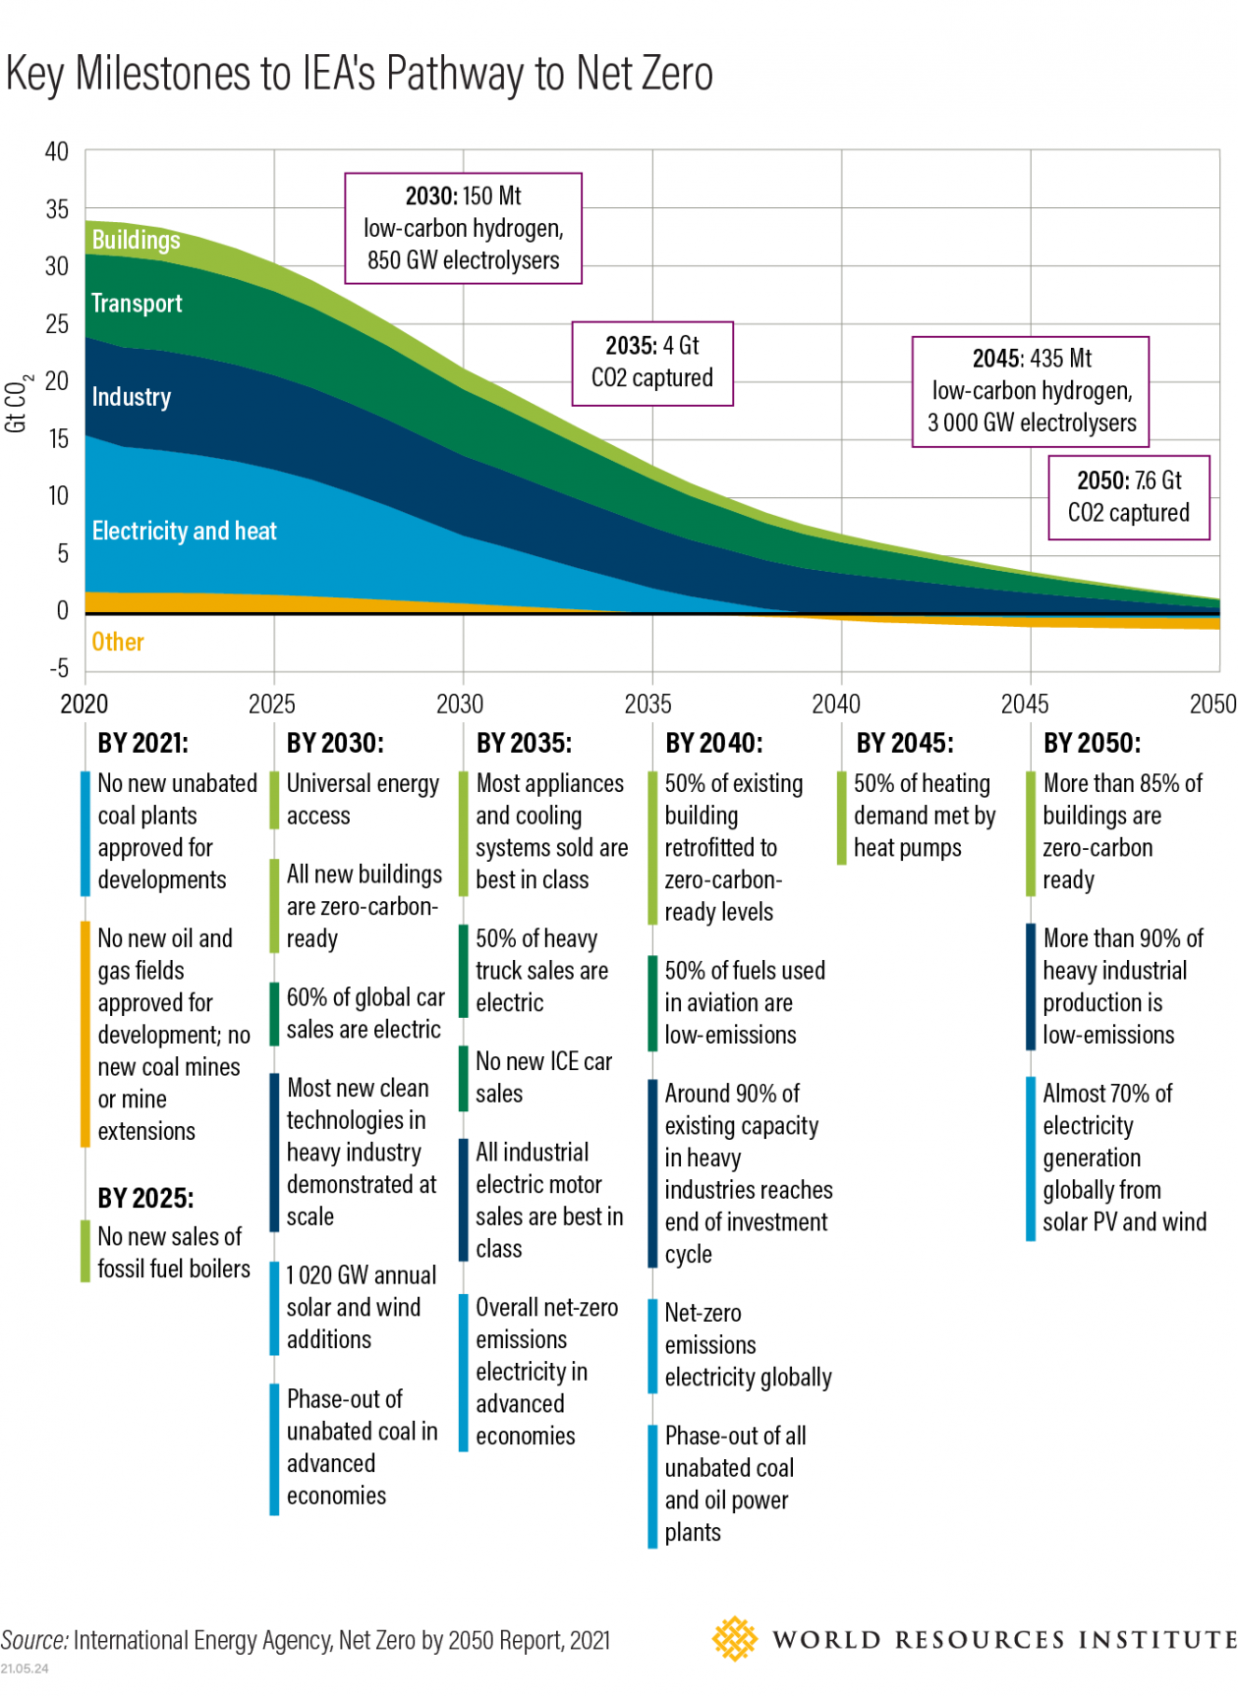

Figure 12: Key Milestones to IEA's Pathway to Net Zero (WRI, 2021)

Comparison of IEA and IPCC scenarios
As discussed earlier, both the IEA and IPCC deliver scenarios regarding the development of emissions. While those are two of the most frequently referred to scenarios that shall be referred to when defining the ambition of net zero pathways, it is important to note the differences of both organizations and scenarios. In regards to the connection to the IPCC, the IEA writes as follows (IEA, 2021):
“To help inform its work on net zero pathways, the IEA engaged in extensive consultations with experts in academia and national bodies that have developed pathways to support net zero pledges made by governments. This includes groups that have developed netzero emissions pathways for several countries including China, European Union, Japan, United Kingdom and United States, as well as the IPCC. These pathways were not used directly as input for the APC, but the discussions informed our modelling of national preferences and constraints within each jurisdiction and to benchmark the overall level of energy‐related CO2 emissions reductions that are commensurate with economy‐wide net zero goals.”
To summarize, while the IEA draws inspiration from the IPCC to some extent, the IPCC’s pathways were not used as direct input for the IEA. Therefore, the scenarios are different, and it makes sense to distinguish between the two.
- Organizational purpose
The IPCC is first and foremost a scientific organization, focused on the assessment of the latest climate science. The IEA’s area of interest is primarily energy policy, with a special focus on what to do to arrive at the end target.

- Focus
When it comes to their scenarios, the IPCC has a global focus independent of the sector, while the IEA is limited on the energy sector.

To go into more detail regarding differentiation, a deep dive into the respective models, assumptions and parameters would be necessary which exceeds the limitations and focus of this comparison. However, the listed differences should give a basic idea regarding the key differences of two of the most frequently referenced inspirations to ensure the ambition level of a net zero pathway is “science-based” in the assessed initiatives.
This sentiment is echoed by the UN’s “High Level Expert Group” , as they reference those two initiatives explicitly in their main recommendation as follows (United Nations, 2022): “All net zero pledges should include specific targets aimed at ending the use of and/or support for fossil fuels in line with IPCC and IEA net zero greenhouse gas emissions modelled pathways […]”.

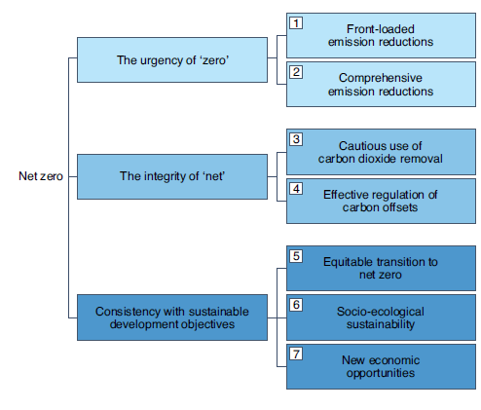
Oxford Net Zero Principles

Figure 13: Attributes of net zero as a frame of reference (Fankhauser et al., 2022)
The “Oxford Net Zero Principles” describe the seven main attributes that were outlined in their nature climate change publication “The meaning of net zero and how to get it right” (Fankhauser et al., 2022). In this publication, the key steps to follow are summarized as shown in Figure 13. While the paper does not pose as a net zero guideline as in specifically what to execute on, it can be seen as a high-level assessment of existing guidelines and important take-aways to take into consideration regarding the scientific integrity of the decarbonization approach that is chosen.
While this does not provide scientific background regarding potential future scenarios, it still describes a peer-reviewed scientific evaluation on target setting itself, which is why it was categorized as a “scientific” document.

Measurement
Measurements describe the documents that are commonly referred to in the analysis of net zero initiatives regarding the measurement and categorization of emissions (such as scope 1, 2 and 3 by the GHG protocol).

GHG Protocol

Background
In order to report their emissions, most companies follow what is widely agreed upon to be the predominant standard for greenhouse gas reporting: the greenhouse gas protocol created by the World Business Council for Sustainable Development (WBCSD) and the World Resources Institute (WRI) (Green, 2010). According to the company’s website, 92% of Fortune 500 companies that respond to the CDP do so using the GHG protocol guidance either directly or indirectly (GHG Protocol, 2022). In an net zero initiatives comparison conducted by Oxford Net Zero, the same was found for the analyzed initiatives as a majority of them aligned with the GHG Protocols guidance, as it was one of the most referenced documents in their comparison next to SBTi and Race To Zero (Mcgivern et al., 2022).

5.1.2 Description
The organization offers a variety of different standards, depending on the needs of the user. For example, there is a standard for cities, products and cooperations (an exhaustive list can be found on the company’s website). For this comparison, the documents for cooperations are especially important. To understand the respective documents, it is important to briefly explain the nomenclature that was introduced by the GHG Protocol. More precisely, to understand the categorization of emissions they introduced, which is now widely used to differentiate between different sources of emissions.

Figure 14: Visualization of scopes (GHG protocol, 2011)
Scope 1 describes direct emissions of a company. This means under this scope fall emissions resulting from a chemical reaction (such as the carbon dioxide resulting from steel production or combustion of natural gas). It is important to note that the origin of those emissions such as boilers or process equipment must be within the control of the reporting company (otherwise they would be relevant for either scope 2 or 3).

Scope 2 includes emissions that occur from the production of energy such as steam, electricity, heating, and cooling that is then consumed by the reporting company. Since the origin of the emissions is not within the company itself, those emissions are called indirect emissions.

Scope 3 accounts for all other indirect emissions not covered under scope 2. The company is therefore indirectly responsible for the emission as those emissions arise because of their actions, however, they are not emitted within the company itself. Due to the diverse nature of scope 3 emissions this category is further divided in 15 subcategories.

Table 1: Comparison of documents by GHG Protocol
Document | Short description
Corporate Standard | Originally published in 2001, the GHG Protocol’s “Corporate Standard” delivered a comprehensive framework to quantify, manage and reduce GHG emissions. It introduced the concept of scopes as described earlier. Under this standard, reporting for scope 1 and 2 emissions is mandatory and scope 3 is voluntary.
Scope 2 Guidance | The GHG protocol describes the document as “the most significant amendment to the Corporate Accounting and Reporting Standard since its inception”. It offers additional clarity on how cooperations measure emissions for scope 2.
Scope 3 Value Chain Standard | This standard focuses on the emission that are located outside of its own walls. Released in 2011, it gives guidance for companies that want to report on their entire value chain (so scope 1, 2 and 3).

As highlighted in Table 1, there is more than one document of relevance by the GHG protocol. For simplicity, in the document the described differentiation will not be explicitly mentioned anymore. Instead, the documents will simply be referred as the “GHG Protocol” – acknowledging that there are several documents that are necessary to cover the whole complexity of the entire value chain.

5.1.3 Key takeaways regarding the GHG Protocol
- The GHG Protocol is the dominant industry standard when it comes to reporting
- The concept of scopes to differentiate between different sources of emissions is used by most net zero initiatives
- Recommends tracking of all Kyoto Gases (often simplified to “all GHG emissions” in net zero standards, therefor the same will be done in this comparison)

International Organization for Standardization (ISO)

Background
ISO is an independent, non-governmental organization with a membership of 167 national standard bodies. It publishes standards for a variety of different industries / technologies (ISO, n.d.-b).
For this document’s purposes, the scope of interest shall be limited to the emission reporting as well as the target setting guideline (ISO 14068, will be described in the target setting section).

Description
In this comparison, the emission reporting documents shall be summarized as “ISO Reporting”, analogously to the approach that was previously described for the GHG protocol. Here, two documents are of importance:
- ISO 14064-1:2018
Standard for GHG reporting of companies at organizational level
- ISO 504 14067:2018
Standard for carbon footprints of products

Key takeaways regarding the ISO Reporting documents
- ISO provides alternative reporting approach to GHG Protocol
- Is the building block regarding reporting to some of the target setting documents

Comparison ISO and GHG Protocol
Both guidance documents have the same focus area: the measurement of GHG emissions. To differentiate between the two, one could try and simplify it as follows: for ISO, the focus is on providing minimum requirements while for the GHG protocol it is more about best practices.
Their methods regarding categorization of emissions also differs, which may not be problematic when one or the other approach is chosen for emission measurement alone. However, it is essentially as the famous saying describes: “if you can’t measure it, you can’t manage it”.
Since this is by necessity the very first step on the pathway to net zero, subsequent steps and guidance documents are somewhat dependent on what document guidance you follow for this first step: measurement. For example, the Science Based Target initiative (SBTi) builds on the GHG protocol. On the other hand, the target setting documents for ISO are – hardly surprising – focused on ISO’s reporting documents.
While ISO provides a comparison of the GHG protocol and ISO reporting in their target setting document, this still implicitly necessitates the willingness and availability of resources of organizations to put additional time and effort into translating their reporting into another system to then be suitable to choose that might not be built upon an entity’s current reporting approach.

Target setting

Origin of comparison criteria
The comparison criteria that are highlighted in this document are a simplified version of a more detailed matrix that is available as an excel worksheet. To quantify the comparison, a certain set of metrics has been chosen for comparison purposes. These metrics have been inspired to some extend by the SBTi’s comparison criteria which were chosen for comparing their own methods. Furthermore, the metrics were compared with the approach of other assessment such as ONZ and Pathways to Paris. While especially the number of documents and scale of analyzed parameters of ONZ far exceeds the scope of this document, the parameters used in this comparison still resonate with the overall concepts of the other two assessments. However, it shall be highlighted that if for some documents or standards even further evaluation and parameter are of interest, the ONZ comparison offers a great starting point.

Criteria for comparison of target setting

Overview (Step-by-Step Process)
Does the initiative describe a clear step-by-step process that needs to be followed in order to join and participate in it?

Suitability
Who can use the standard? While a more extensive list is available in the comparison excel (based on what the documents themselves state regarding who can or cannot use their standards), it is here simplified to the following target groups:
- Cities
- Products
- Corporations

Quantification and Reporting
Here the question is answered: which reporting standard should be followed?

System Threshold
The system threshold answers what scopes shall be included, the emission threshold as well as what greenhouse gases to be included.

Offsetting
To compare the different offsetting approaches, they were assessed using the so called AVID+ framework of John Sterman from MIT (John Sterman, 2022). He defined five main components to assess the quality of offsets:
- Additional: reduce emissions that would not otherwise be cut
- Verifiable: verify that the emissions savings occur
- Immediate: Immediate reduction of carbon, not at some point in the future
- Durable: it must be ensured that the emissions are contained
- +: Offsets should multisolve — they should advance other goals such as job creation, poverty reduction, health care, and social justice, in addition to their climate benefits
While the “+” component also offers valuable insights, it is even harder to quantify than any of the other criteria because it is the least specific and rather ambiguous. Essentially, to evaluate this point, another set of criteria would have to be introduced to justify it being fulfilled or not. For that reason, it shall be neglected for the moment. Therefore, the framework will be addressed as AVID framework from now on. It shall also be noted here that the level of detail in which the assessed initiatives address the respective points differs, however, this fact was not considered in this comparison as this would add another level of complexity to the topic in regard to how to evaluate the completeness of each subcategory.

Targets/Methods
For this point, the question is answered whether any specific emission reduction targets are available. Furthermore, the question arises if any methods are introduced in regard to how those targets shall be meet, in effect if there are any constraints in regard to how I can create the pathway that leads me to my desired reduction target.

Sector specificity
Sector specific targets and methods assesses whether methods or targets are also available on a sector specific level.

Intermediate Targets
An intermediate target in the context of this document shall be defined as a target that is located between the time of joining the initiative and the end state target that the initiative proposes (e.g. net zero).
- Required: Is it necessary to define intermediate targets?
- Ambition: How ambitious is the target (relative to IPCC’s degree Celsius targets)
- Timeline: When shall the intermediate target be reached?
- Numerically defined: Is there a clear relative or absolute reduction target defined by the standard?

End state Target
This is the final state that can be reached when following the guidance of the initiatives compared in this document (in effect net zero or carbon neutral).
- Name: Now does the initiative call the end state that can be reached under its guidance?
- Required: Is it necessary to define such an end state?
- Ambition: How ambitious is the target (measured in relation to IPCC’s °C scenarios)
- Timeline: When shall the end state target be reached?
- Numerically defined: Is there a clear relative or absolute reduction target defined by the standard? For the end state target, this means in effect whether the residual emissions are defined or not.

Science Based Targets initiative (SBTi)

Background
The SBTi is a partnership between CDP, the United Nations Global Compact, World Resources Institute (WRI) and the World Wide Fund for Nature (WWF). Created in 2014, the organization had the ambition to “[…] raising climate ambition in the corporate sector by driving the adoption of climate targets in line with best-practice, and with science”.
The SBTi defines the areas they are active in as follows (SBTi, n.d.-a):
- Defines and promotes best practice in emissions reductions and net-zero targets in line with climate science
- Provides technical assistance and expert resources to companies who set science-based targets in line with the latest climate science
- Brings together a team of experts to provide companies with independent assessment and validation of target

Comparison outcome
The SBTi has released a guidance document in 2021 called “SBTi corporate net zero standard” (SBTi, 2021). In this document they outline their approach on how to set net zero targets in line with the IPCC’s 1.5-degree scenario.
For their target setting processes, in general, SBTi offers two different method categories with multiple different methods in each depending on scope and target (long-term or interim target) (SBTi, n.d.-a):
Cross-sector pathway
This is essentially the SBTi’s version of a one-size-fits all pathway. Starting at a base year, it requires a yearly absolute reduction relative to the base year (to stay in line with 1.5°C that means a reduction of over 4.2% annually). This can be used by (almost) all sectors.
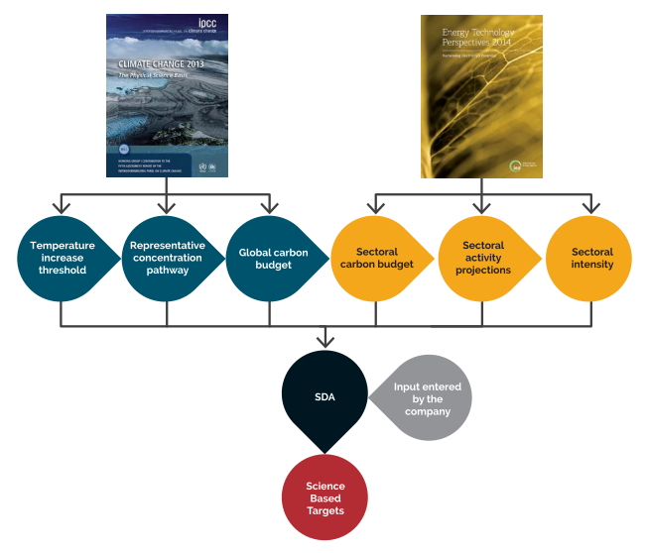
Sector-specific pathways
The so called sectoral decarbonization approaches (SDA’s) are specific to industry sectors. The targets can be set as a relative or absolute target.
For the sector specific targets, the SBTi has drawn inspiration from several sources, including but not limited to the IEA’s and IPCC’s forecasts that were described in earlier chapters, as outlined in Figure 15 (SBTi, 2015). By doing so, the SBTi has finished 7 sector specific guidance documents, with another 7 currently being developed.
SBTi not only allows sector specific approaches, but furthermore allows different methods based on scope and timeline (long- or short-term target), leaving a lot of flexibility regarding how to define a company’s net zero pathway while making sure it still meets the requirements of SBTi.
Figure 15: Visualization of SBTi's SDA (SBTi, 2015)
In general, SBTi offers guidance with a very high level of specificity regarding their requirements. Those requirements are also comparably high, following so called “Pace-Setter” principles in many areas. However, for some areas such as Scope 3, the requirements are lowered – showing the depth of consideration that SBTi offers.
Furthermore, SBTi is very transparent regarding how it derives it requirements to be in line with science.

SBTi as arguably the standard with the highest reputation when it comes to target setting
Overall, the SBTi has arguably the highest reputation and suitability of all the analyzed target setting documents to model a decarbonization pathway on. This is the result of this comparison but can also be derived from external sources.
CCCA Assessment of industry standards
In the assessment that builds the basis of this document, the Science Based Target initiative had the highest level of specificity regarding the requirements as well as the guidance that it provides. This far exceeds the analyzed areas mentioned in this document. Just to mention one example in this regard, SBTi is one of the few guidance documents that delivers specific guidance regarding setting a base year. Only a minority of initiatives assessed by ONZ (5/33, or 15%) specify a base year and offer guidance on how to determine baseline emissions for reductions targets (Mcgivern et al., 2022)
To illustrate the ambitious requirements that SBTi has introduced with their net zero standard, BCG has compared the current industrial net zero landscape to the requirements of SBTi (Figure 16). This demonstrates both the high requirements of SBTi but also the gap between the status quo and what the SBTi deems as necessary to get on track regarding limiting global warming to 1.5°C.
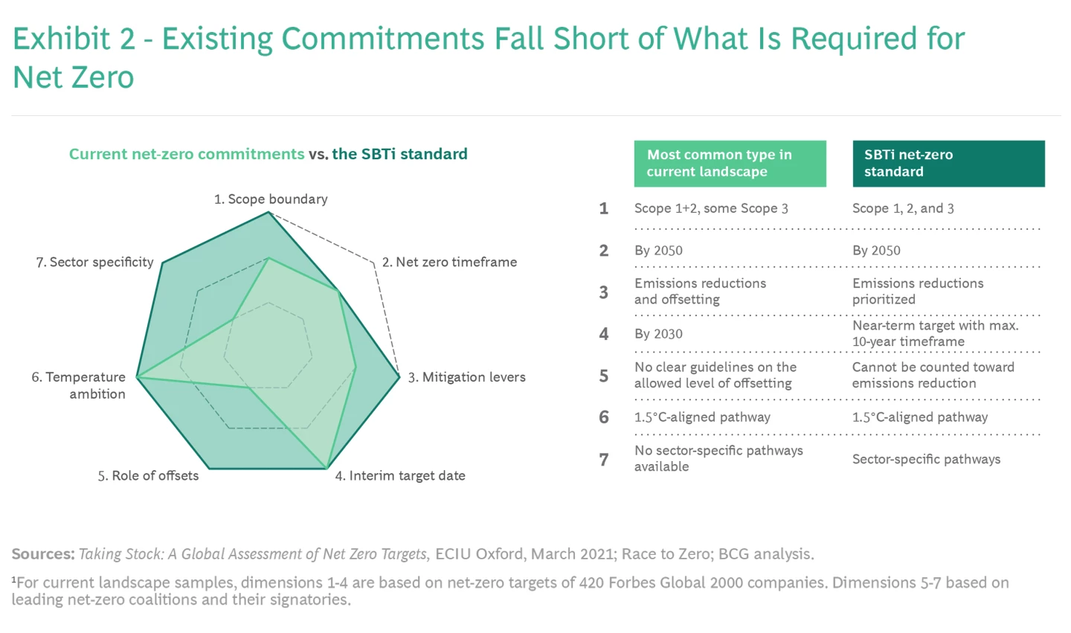
Figure 16: Comparison of industry net zero targets vs. SBTi requirements (BCG, n.d.)
While this assessment was specifically carried out to compare existing industry targets with the requirements of SBTi, the results also translate well as a comparison of SBTi to other industry standards.
Overall, from the documents assessed in this comparison, the SBTi delivers by far the highest level of detail and requirements when it comes to target setting. Furthermore, it not only provides clear timelines for intermediate targets, but defines a pathway on a year-to-year basis. Therefore, for the SBTi, the pathway to net zero is not just an undefined way towards “zero GHG emissions”. Instead, the initiative takes a step further and makes sure that that the entire pathway is on track with the carbon budget that the emission scenario allows.
Under these constraints, it introduces a variety of different methods. Depending on the scope that is targeted and the sector the company is in there are various ways how science-based targets can be set.
It also specifically defines for each of these pathways what “net zero” constitutions. This means independent of the pathway chosen, when it comes to residual emissions SBTi sets clear, numerical targets regarding what is an acceptable level for “residual emissions”. Other standards rarely get anywhere close to the level of specificity that SBTi does, although they might use similar concepts or requirements, or straight up reference SBTi as an indicator of what “unabateable emissions” might be.

Other assessments of industry standards on SBTi
Oxford Net Zero
Oxford Net Zero states the following regarding SBTi (Mcgivern et al., 2022):
“There is an expectation across initiatives that target-setting on the path to net zero to be based in independent, peer-reviewed science-based pathways. Among the initiatives reviewed, the Science Based Targets initiative offers the most robust guidance on this, and several initiatives point back to this one.”
This is very much the same conclusion as the assessment of the standards in this document can provide. Many of the documents assessed in this comparison referred to SBTi either directly or indirectly (for example by giving exemplary targets that resembled those of SBTi) as guidance for how to set science-based targets.
Pathways to Paris
Pathways to Paris describes SBTi as a standard that is increasingly establishing itself as an orientation standard for decarbonization (Pathway to Paris, n.d.) Furthermore, it defines SBTi as one of only four (out of 22) assessed initiatives they categorize as “very helpful” in regards to the net zero transformation.
Politics on SBTi
UN expert group
The standard is also referenced by experts appointed by politics. To give an indication of the SBTi’s relative standing, when the UN created the previously referenced “United Nations’ High-Level Expert Group” – SBTi was the very first initiative that was approached for consultation, ahead of any single other entity. In their standard, they reference it multiple times as an initiative to derive target setting principles from (United Nations, 2022).
White House (USA)
In the end of 2022 the White House published a plan to “Protect Federal Supply Chain from Climate-Related Risks”, which – if executed – would necessitate government contractors to set targets in accordance with SBTi and reporting to the CDP (The White House, 2022).

Assessment of Industry stakeholders on SBTi
NatCen
In NatCen’s assessment, the common view among their interviewees was that (NatCen, 2022):
“[…]SBTi has become the “de facto” organization for setting Net Zero standards, with good resourcing and access to advisory experts”.
The sentiment in regards to other standards and initiatives goes as far as the following statement (NatCen, 2022):
“[Standards for Net Zero target setting have already] been done by Science Based Targets. It's not perfect, but it has been done. The way in which ISO and BSI can contribute is to stop chasing that, and start to integrate climate change action into all of the family of standards that it has already.”.
As mentioned earlier, NatCen’s assessment this quote was quoted from was financed by BSI, the fact that a statement clearly criticizing the financier of the study was none the less highlighted within the publications speaks volumes regarding the scientific integrity of the assessment as well as the popularity of the sentiment within industry stakeholders.

ISO/CD 14068:2022

Background
ISO was described in further detail in the reporting section.

Description
While it shall be noted here that the document provides guidance that exceeds pure target setting (such as offsetting requirements), as the main purpose of this document is the comparison of decarbonization documents and this is also the focus of the ISO 14068 standard, it shall be classified as a target setting document.
ISO 14068 directly builds upon ISO’s reporting document, it can therefore be seen as an extension of those previously introduced documents in regard to target setting.
The end state that the document aspires towards is not “net zero”, but “carbon neutral”. Although the name suggests otherwise, the focus is on all greenhouse gas emissions. This is a direct break from the terminology originally introduced by the IPCC (Figure 4).
While this may seem confusing as first, the easiest way to make sense of the name may be to consider its approach towards offsetting. Here, a company can essentially become carbon neutral by carbon offsets alone – this means offsets that have the purpose of carbon dioxide extraction out of the atmosphere. Therefor the carbon in carbon neutrality can be interpreted as being related to the type of offset that is used (carbon dioxide). None the less, while the differentiation of the concept from net-zero makes sense in regard to its content, it is hard to comprehend why this would have to be based on a previously defined terminus that means something entirely different (no net emission of CO₂).

Comparison outcomes
Similarly, to their reporting counterparts, ISO 14068 aspires to provide minimum requirements regarding target setting. It does so in detailed fashion when it comes to qualitative attributes that shall be followed, however, quantitatively it lacks the detail of SBTi. The difference could be defined similarly to what was previously discussed regarding the GHG Protocol and the ISO documents for reporting purposes: SBTi tries to define best practices while ISO defines minimum requirements.
Furthermore, the concepts of net zero and carbon neutrality are very much different as described in subsequent sections.
One of ISO’s short-comings (intentional or not) relative to standards such as the SBTi is its ambiguity. For example, ISO defines residual emissions as follows (ISO, 2022):
Residual GHG emissions are characterized as GHG emissions within the carbon footprint of the subject that remain after implementing all technologically and economically feasible measures. The threshold between unabated and residual GHG emissions will adjust over time as technology improves and economics change.
While overall the description is sound and closely matches the concept that SBTi or other standards use for their residual emission – this does not help if an entity wants to know what that means for them regarding their residual emissions. Without any numerical specifications the definition above is ambiguous at best. Therefor different entities will derive at different conclusions when it comes to determining a feasible emission threshold.
The standards goal is to govern “carbon neutrality”. As described earlier in more detail, this means the role of offsets is comparably higher for this end state. However, it shall be noted that this is reflected in ISO’s requirements regarding offsets, where ISO 14068 is one of only two initiatives that were able to address all assessment criteria from the AVID framework.

Race To Zero

Background
Race to zero described itself as follows: “Race To Zero is a global campaign to rally leadership and support from businesses, cities, regions, investors for a healthy, resilient, zero carbon recovery that prevents future threats, creates decent jobs, and unlocks inclusive, sustainable growth.”. It mobilizes a variety of different entities to join what Race to Zero describes as the “largest-ever alliance committed to achieving net zero carbon emissions”: the Climate Ambition Alliance (UNFCCC, n.d.).

Comparison outcomes
In some areas, Race to Zero establishes pace-setter attributes where it decides to specify it’s requirements, however, there are also large areas where it is (intentionally) rather unspecific and ambiguous (Race to Zero, 2022). As a testament to this statement, Race to Zero has released a expert peer review of their criteria to: “provides additional guidance regarding how the Expert Peer Review Group interprets the Race to Zero criteria, and how Partners and their members can expect to implement these criteria” (Expert Peer Review Group, 2022). In the context of this comparison, the interpretation of the expert group has been considered as definitive and extended the Race to Zero requirements (so criteria only derived by the literal statements of Race To Zero Criteria 3.0), as the expert group has arguably a better understanding on how to interpret the criteria, and there for their conclusions were interpreted as requirements as well. This differs for example from what Pathways to Paris did for their evaluation, as they have arguably only considered the criteria itself without the expert assessments, which shows in some categories such as required scopes.
Race to Zero, next to SBTi and the GHG protocol, is one of the most referenced documents analyzed by ONZ.
Apart from the minimum requirements, Race to Zero also offers “Leadership” principles for organizations that want to take their ambitions one step further in certain (or all) areas. By doing so, they offer both minimum requirements as well as goals to aim forward. This is a similar approach as used by initiatives such as the CDP, where the company has a specific rating based on its environmental performance.

6.5.3 Race to Zero and SBTi
Overall, the organization gets specific in many areas – in other, it shifts responsibility towards the company and other guidelines. However, Race to Zero does not have to be seen as a “stand alone” initiative, on the contrary. Race to Zero lists an extensive list of partners on their website (Race To Zero, n.d.). Among those, the Business Ambition for 1.5°C is prominently listed at the first position, which is “[…] a campaign led by the Science Based Targets initiative (SBTi) in partnership with the UN Global Compact and the We Mean Business”. So essentially, instead of offering yet another approach to decarbonization it likely is more reasonable to simply interpret Race to Zero and SBTi (and the other listed partners) as extensions of one another (not conceptually but regarding ambition) with the purpose of motivating as many people as possible to join and set targets in line with climate science.
This is also demonstrated by their approach towards a variety of things. For example, both initiatives base their end state terminology on the IPCC’s nomenclature.
SBTi offers a much more detailed pathway, however, the general principles of SBTi and Race to Zero, while slightly differing in some details, follow a similar overall concept and are easily comparably and transferable due to their shared nomenclature. For example, it could be argued that both initiatives follow the so called “carbon law”. However, the specific execution slightly differs as SBTi necessitates an approximate 50% reduction of emissions relative to a 2018 base year in 2030 (in case this base year is chosen). For Race to Zero, a 50% reduction on CO₂ is required.

2030 Breakthroughs

Background
Breakthrough 2030 is “a strategy paper that covers over 30 sectors that make up the global economy, with specific attention on oil & gas, fashion and finance, as well as new sectors: pharma, tourism, Carbon Capture Usage & Storage (CCUS) and Direct Air Capture” (Climate Champions, n.d.).
The breakthroughs are derived from the Climate Action Pathways, a set of comprehensive roadmaps to achieve the Paris Agreement in line with 1.5°C across all sectors. The ambition of the initiative is to recruit 20% of the key actors in each sector into Race to Zero.

Comparison outcome
Essentially, Breakthrough 2030 should not be seen as a standalone document, but rather an extension of Race to Zero with focus on sector specific actions. It is not the only document of that kind, as there are other documents related to Race to Zero, some of which are analyzed in the Pathways to Paris comparison.
Similarly to Race to Zero, it should be understood less as a detailed guidance for decarbonization such as SBTi, but rather a framework of goals that shall be achieved to enable a world that is on track to fulfill the ambitions declared in the Paris Agreement.
In that sense, the document offers sector specific ambitions. For example, for the electricity system, the paper offers ambitions both for the intermediate target (solar and wind power make up at least 40%, and all renewables make up at least 60% of global electricity generation by 2030) and the end state goal: a decarbonized electricity system by 2040 (Climate Champions, n.d.). This ambition is in line with the SBTi’s sector specific goal for the power sector, which also requires net zero by 2040 for this specific sector (SBTi, 2021).
However, apart from pure decarbonization pathways that can be compared to sector specific guidance’s from SBTi, the guideline also defines global production targets, such as for green Hydrogen. For this promising molecule, the paper has an overall green Hydrogen production goal by 2026 and 2050 respectively.

6.6.3 Sectoral approaches of SBTi and Breakthrough 2030
While both initiatives offer sector specific focus, the ambitions and focus are very different. Breakthrough 2030 tries to fulfill high level targets, while SBTi breaks target setting down to the most granular unit (one company) and defines the pathway on this level of detail.
As such, as described earlier when relating SBTi and Race to Zero, the two initiatives should not be seen as riveling approaches, but rather complementary to each other.

IWA 42

Background
An international workshop agreement, or short IWA, is a document prepared to respond to urgent market requirements. These are prepared through a workshop mechanism outside of ISO’s committee structures, including a broad range of interest groups (ISO, n.d.-a).
The IWA 42 specifically “[…] provides guidance on what governance organizations and other organizations can do to effectively contribute to global efforts to limit warming to 1,5 °C by achieving net zero no later than 2050” (ISO, n.d.-c).

Comparison outcomes
The IWA 42 offers an interesting objective, as it describes its intent to “[…] complement voluntary initiatives and facilitate alignment, so that any organization looking to make or support a net zero claim takes a similar approach regardless of the initiative it is associated with” (ISO, 2022).
In doing so, the standard offers a higher specificity than ISO 14068 does in alignment with IPCC and the requirement details such as timeline and quantitative aspects of targets. This would support the interpretation that was formulated earlier that, perhaps, ISO should be seen more as a minimum requirement in some areas.
The approach of IWA 42 seems like a relatable idea, which is to bring different initiatives together under one umbrella. This is true for reporting, as well as different end states (carbon neutrality or net zero).
However, it is a little ironic that IWA 42 tries to solve the problem of missing unity by introducing a concept that in order to provide the aspired comparability also requires unity (under IWA 42). So arguably, if the IWA 42 could somehow create unity amongst net zero initiatives it might be simpler to do so without the inclusion of IWA 42 which would reduce the minimum amount of initiatives involved in the target setting process by one.

Umweltbundesamt DE

Background
The German Umweltbundesamt is Germanys central environmental agency (Umweltbundesamt, n.d.). In 2021 they released a guidance document for administrations titled “The path to greenhouse gas neutral administration” (Umweltbundesamt, 2021).

Comparison outcomes
The document focuses on practical recommendations for the path towards net neutrality, primarily for administration as the title suggests. In doing so it does not really set it’s own necessities regarding the pathway to be chosen but references external political frameworks German administrations have to work towards. It echoes common sentiments found in other net zero initiatives with specific focus on administrations, where it offers detailed guidance down to sector specific areas.

PAS 2060

Background
PAS 2060 specifies how to reach carbon neutrality, created, and published by the British Standards Institute. The standard was first published in 2010 and then updated in 2014 (BSI, n.d.).

Comparison outcomes
Similarly to what ISO describes for their carbon neutrality guidance, the standard has requirements on offsets while lacking specificity in areas such as timeline, ambition and residual emissions. The concept of carbon neutrality, it’s implications and differentiation from net zero explained in detail in previous sections.
It shall be noted that PAS 2060 version can be certified by TÜV – in German under the name of “klimaneutralität”.

Offsetting
The general principles that were highlighted for offsetting were already discussed in previous sections. This category is for document’s whose focus is on setting boundary conditions for carbon offsets.

The Oxford Offsetting principles

Background
The Oxford Offsetting Principles, launched by the University of Oxford, describe its content as “an essential resource to guide the design and delivery of voluntary net-zero commitments by government, cities and companies.” The standard delivers principles to build credible carbon offsetting upon.

Description
The Oxford offsetting principles were referred to for the practice of determining the quality of carbon offsets. For example, SBTi highlights its own inadequacy regarding the definition of proper offsetting and is currently working on improving in that area. In the meanwhile, apart from its own guidance SBTi refers to several guiding documents – among those the Oxford Offsetting Principles (Allen et al., 2020).
In the document, they outline many offsetting related principles that are echoed in some of the analyzed standards. High level best practices that were also mentioned in many of the other standards include but are not limited to:
- Prioritization of emission reduction over offsetting
Essentially, the highest quality offset an entity can buy is none.

- Carbon removals over emission reductions
Carbon removals scrub emission directly from the atmosphere. According to the Oxford Offsetting principles, most offsets today are emission reductions. Organizations shall commit to gradually change towards carbon removals, with the final goal of “[…] ultimately reaching 100% carbon removals by mid- century to ensure compatibility with the Paris Agreement goals”.

- AVID+ framework
Essentially, the requirements that are described in the AVID+ framework are echoed in many standards as well as in the Oxford offsetting principle except for one: “immediate”. Only ISO 14068 and PAS 2060 addressed this requirement, it could therefore be categorized as a “pace-setter” attribute.

Reporting

CDP (formerly Carbon Disclosure Project)

Background
The CDP describes itself as a “[…] not-for-profit charity that runs the global disclosure system for investors, companies, cities, states and regions to manage their environmental impacts. The world’s economy looks to CDP as the gold standard of environmental reporting with the richest and most comprehensive dataset on corporate and city action”. Created in the year 2000, it covered over 13000 companies worth an accumulated 64% of global market capitalization in 2021, an increase of 37% relative to the year 2020 (CDP, n.d.-b).

Description
The CDP encourages companies to disclose environmental information, such as but not limited to their emissions. When companies do so, they are graded from A to F, as a measure of their environmental stewardship. Or, as the CDP puts it: “We use our scoring methodology to incentivize companies to measure and manage environmental impacts through one or more of our climate change, forests and water security questionnaires” (CDP, n.d.-c).
Among those parameters that are assessed, one of the variables of importance is the decarbonization pathway that is chosen, and whether it is in line with a 1.5°C pathway. To achieve the CDP’s highest rating – which is listed as A or “Leadership”, a corporation will “[…] undertake actions such as setting science-based targets”. As one of the co-founders of the SBTi, this can be interpreted as a direct reference to the SBTi. This means de-facto that to achieve an A rating at CDP (CDP’s highest rating) it is necessary to join SBTi. Therefor it is fair to summarize that regarding target setting the CDP is (hardly surprising) in line with the initiative it co-founded for the specific of setting science-based targets.

European Sustainability Reporting Standard (ESRS)

Background
On January the 5th 2023, the Corporate Sustainability Reporting directive (CRSD) entered into force following the request of the European Commission. This will require a total of roughly 50000 companies to report on sustainability. Those companies will have to do so according to the so-called European Sustainability Reporting Standards (ESRS) that is analyzed in this document.
The new rules shall ensure environmental transparency. Those rules will have to be applied in the financial year 2024 for the first companies (to allow reporting in the year 2025) (European Commission, n.d.-a) .

Comparison outcome
While the comparison matrix was initially designed for documents that are primarily about the target setting process, due to the overlap of content it made sense to evaluate the document using the same principles as described within the target setting section. By doing so, it is the only non-target category initiative within this sector.
The reporting standard itself has many general requirements (such as reporting of all scopes), however, on other issues, it simply states the company shall report whether it follows this principle. For example, the standard declares that: “[…] the undertaking shall state whether the GHG emission reduction targets are science-based and compatible with limiting global warming to 1.5°C “. This does not necessitate for a 1.5°C alignment to be the case, however, follows the general aim of the ESRS and increases transparency in this regard.
As such, the comparison within the target setting matrix is potentially not fully suitable for this initiative category, however, since the other assessments (ONZ and Pathways to Paris) also include documents and initiatives from other categories (for example the GHG protocol) the inclusion of this document due to high contextual overlap was still determined as appropriate. ESRS shows a high overlap with SBTi regarding terminology, concepts, and ambition.

ESRS and CDP
Both listed reporting initiatives fill a very similar function. It remains to be seen how the implementation of the ESRS will affect the role of CDP in the European business realm. Judging by the CDP’s recently published call for support for the implementation of the ESRS, the CDP might expect its importance to increase as well if its questionnaire is aligned to the requirements of the ESRS (CDP, n.d.-a). Furthermore, by doing so, it could potentially act as a bridge between the requirements in the US and those in Europe. The necessity for such an alignment is very real given the proposed European carbon tax law (The New York Times, 2023). What effect the ESRS will have on CDP’s business remains to be seen, but it can be might argued that this might solidify CDP’s role even further.

Net zero guidance comparison

Overview (Step-by-Step Process)
Out of the analyzed guidance documents, only 2 documents do not include a step-by-step process.
Firstly, IWA 42 does not provide a clear and summarized Step-by-Step execution process. However, this is most likely due to the role the IWA has defined for its standard, as it defines the documents purpose as follows: “This document is intended to complement voluntary initiatives and facilitate alignment”(ISO, 2022). Therefore, the focus is more on aligning different carbonization approaches to make them comparable instead of introducing a new approach with a step-by-step model.
For the ESRS, the document is from another category (Reporting). However, due to a high overlap in assessable parameters it was still included in the evaluation matrix. No real step-by-step process is listed as it would not serve any real purpose, as the documents’ purpose is to provide a list of criteria to report on.

Suitability

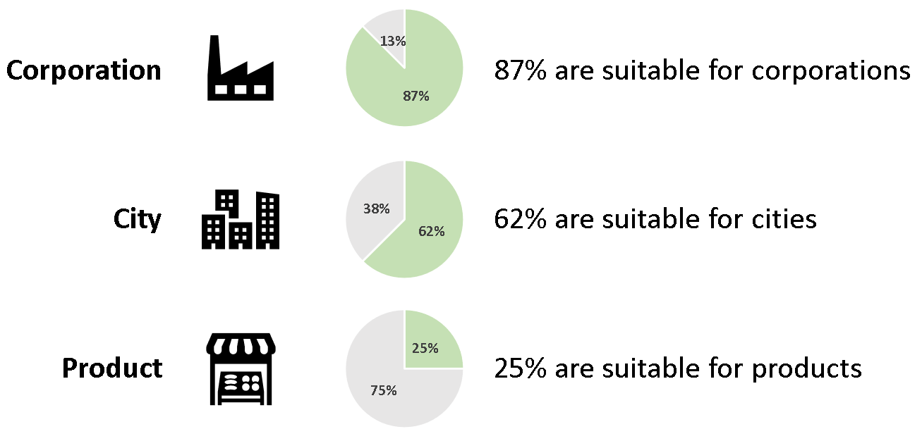

Figure 17: Visualization of suitability of analyzed standards

- Corporations
The only standard that does not include corporations as a target group is the net zero guideline by the German Umweltbundesamt, although the standard states that the included information is also relevant for corporations.

- Cities
Most initiatives and standards can also be applied to cities, although notably to a lesser extent.

- Products
Out of the assessed documents, only ISO 14068 and PAS 2060 specifically tailors towards product level decarbonization, based on their reporting document that focuses on the same. Therefore, when it comes to target setting currently products are limited towards the “carbon neutrality” approach at least judging from the assessed standards.

Quantification and Reporting
Out of all the assessed documents, the majority of target setting documents relies on the GHG protocols guidance when it comes to measurement of emissions. This is in line with what the industry is currently doing, as the GHG protocol is the predominant standard as described earlier. 67% of the initiatives that were analyzed by Oxford Net Zero rely on the GHG protocols guidance, which could be interpretated as an acknowledgement of the document’s role regarding the measurement of greenhouse gases. It is common practice to include all GHGs in the measurements (Mcgivern et al., 2022).
It shall be noted here that there is some inconsistency in the standards when it comes to the reference of “all” GHGs or the Kyoto gases. However, when looking at the overall role of the Kyoto gases for anthropogenic emissions the difference could be argued as almost negligible (EPA, n.d.). However, as pointed out by the GHG protocol, even emissions sources that are currently minor speaking may become larger relatively speaking in the future when other sources of emissions get reduced. As such, it may become important to re-evaluate this inconsistency in the future (GHG Protocol, 2012).
Some guidance documents are building upon the ISO reporting documents, or at least recommend their usage. As previously mentioned, this creates a divide between documents that rely on the GHG protocol as previously shown in Figure 3, versus documents that build upon ISO. Finally, there are also initiatives such as IWA 42 that do not specify and try to bridge the gap. While this may initially seem like the best approach, some details regarding practicality are to be questioned. For example, when it comes to terminology the first difference that becomes apparent is the classification in scopes, for the GHG protocol famously divided in scope 1,2 and 3. ISO does not offer the same differentiation concept, therefor the target setting document is left with the rather challenging decision of either being unspecific or trying to somehow satisfy both concepts simultaneously.
While ISO 14068 provides a comparison between scopes of the GHG protocol as well as ISO, therefor offering the possibility of translation, as previously mentioned this still means additional resources must be spent to bridge that gap. Especially in areas like scope 3 that are challenging enough when it comes to data availability and classification, another consideration on top may further increase the complexity.

System Threshold
For greenhouse gases, all the analyzed documents recommend target setting upon the entire value chain (so in effect scope 1, 2 and 3 or in the case of ISO the corresponding differentiation) as well as all emissions to be involved. This is in line with the findings of Oxford Net Zero, which discovered that around 76% of organizations recommend the measurement of all greenhouse gases ahead of net zero-target setting (Mcgivern et al., 2022). The assessment of Pathways to Paris found in their assessment of 22 standards, 12 of those or roughly 55% of the initiatives required all scopes to be included.
37.5% of the standards (3/8) assessed by CCCA also state a minimum requirement regarding how much of the expected total emissions shall be measured. SBTi takes this one step further and differentiates between scopes as well as targets (so interim and end state target). For example, regarding scope 3, the intermediate target shall cover 67% of the emissions, while the net zero target shall cover 90%. In comparison, scope 1 and 2 shall cover 95% of emissions for both targets. This could be interpreted as a clear acknowledgement of the complexity that scope 3 poses for industries, in comparison to the maturity of scope 1 and 2 reporting. The chosen approach to lower the threshold for companies, which otherwise has very high requirements demonstrates the level of thought and specificity of SBTI.

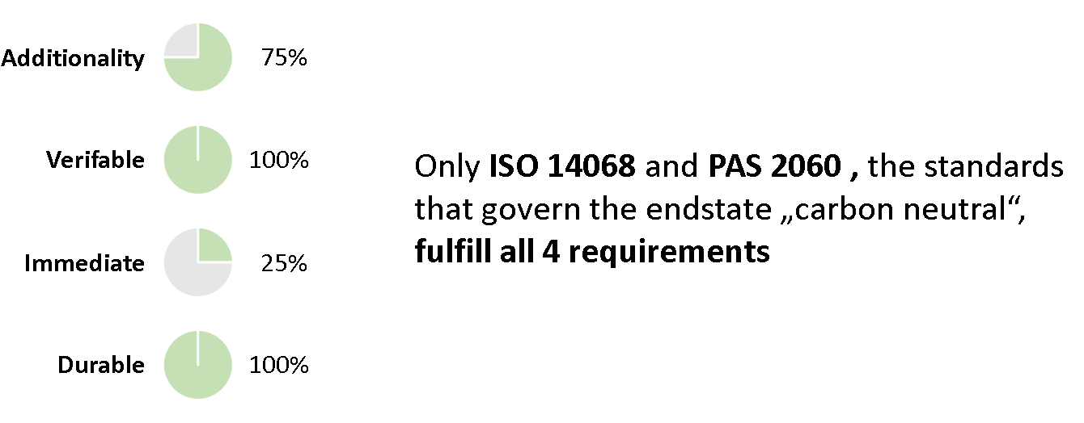
Offsetting
Figure 18: Visualization of offsetting findings

When it comes to offsetting, two organizations stand out when it comes to their requirements: ISO 14067 and PAS 2060, as they addressed all the points necessary to fulfill the AVID framework. SBTi has acknowledged the need for more details in regards to the specifics of neutralization, and is currently working on progress in this area (SBTi, n.d.-c).
According to the Oxford Net Zero comparison, 76% of the standards recognize the role of offsets regarding decarbonization and recommend “high quality” offsets, using similar principles as the AVID framework used in this comparison document. However, there is a lack of guidance what “high quality” offsetting specifically entails.
Only 2 standards address that offsets shall be “immediate”, it could therefore be framed as a pace-setter attribute.
The nomenclature used for offsetting related terms was also assessed (comparison matrix in corresponding excel), and inconsistencies in the usage of nomenclature noted.

Targets/Methods
Out of the analyzed standards, 75% (6/8) initiatives reference specific targets. For the rest (ISO and PAS 2060), they don’t offer specific targets that shall be reached. A sentiment that is stressed however, in this context is to base the targets in “science”.
In the comparison “Pathway to Paris”, 41% (9/22) of the standards provided either a long- or short-term target (or both).

Sector specificity
For different sectors, SBTi, Breakthrough 2030 as well as the net zero guidance of the German Umweltbundesamt offer sector specific information and approaches. While other standards don’t provide the same sector specific approaches, they sometimes referred to SBTi or Breakthrough 2030 in that regard.
This matches with BCG’s assessment of the current industry targets (Figure 16), where in general a lack of sector specificity was found when analyzing the current net zero landscape in the industry.

Intermediate Targets
In this comparison 75% (6/8) of the analyzed net zero standards require an intermediate target. In the Oxford Net Zero comparison, 55% require a net zero target to be set – and in the Pathway to Paris comparison it is roughly 36% (8/22).
Oxford Net Zero notes that „Pace-Setters” require a reduction target that is “in line with the general principle of 50% reduction of emissions by 2030 from a 2018 baseline, with fair share in mind” (Mcgivern et al., 2022). In the compared documents in this comparison, SBTi, IWA 42 as well as Race to Zero/Breakthrough 2030 are among those “Pace Setters” (although it shall be noted Race to Zero limits the reduction to CO₂ emissions).
Regarding the timeline most standards recommend an intermediate target around 2030. From there, some initiatives such as the IWA 42 recommends intermediate target every 2 to 5 years until the end state is reached. For the SBTi, it could be argued that each year until the arrival at “net zero” is an intermediate target since the pathway to get there is defined on a year-to-year basis.
62.5% (5/8) of the analyzed standards have intermediate target in line either with 1.5°C or well below 2°C, and are therefore Paris conform. SBTi differentiates between scope 1 and 2 (1.5°C) and scope 3 (well below 2°C) for short term which then converges to 1.5°C for all scopes for net zero.

End state Target
Regarding end state targets, 75% (6/8) of the analyzed initiatives target “net zero” as an end state while 25% (2/8) of the standards name their end state “carbon neutral”. While both terms were initially defined by IPCC (Figure 4), only “net zero” follows IPCC’s definition of net zero emissions. Carbon neutrality as a concept is a direct contradiction to IPCC’s nomenclature. While the IPCC’s concept of carbon neutrality specifies net-zero-CO2-emissions, carbon neutrality (purely from an emission standpoint) defines net-zero-GHG emissions, just as IPCC’s concept for net zero. This means that from an emission incorporation standpoint alone, net zero and carbon neutral on a corporate level cannot be distinguished. To do so, the requirements on issues such as offsetting must be considered as well as outlined in Figure 5.
8/8 (100%) necessitate setting an end state targets, with 62.5% (5/8) recommending 2050 or earlier. Oxford Net Zero’s comparison had 48% of their initiatives stating the same. Pathway to Paris found that 9/22 (41%) of their analyzed initiatives had long term targets defined, with most also being around 2050 and some as early 2030 for net neutrality.
As described earlier, most standards require the targets to be “science-based” without really specifying what that means in detail. Several initiatives that were reviewed in this document, as well as by Oxford Net Zero, point back to the Science Based Targets initiative as the initiative with the scientifically most robust guidance (Mcgivern et al., 2022).
Most analyzed initiatives write about the importance of reducing emissions until “residual emissions” are reached, which roughly means to reduce emissions to a point that is economically and technologically feasible. 45% of initiatives analyzed by Oxford net zero recommend limiting offsetting to those residual emissions, it states that many initiatives do not state what emissions are “not feasible to eliminate”. Oxford Net Zero clearly highlights SBTi as a Pace-setter in this regard, as one of the few initiatives that does so.

Conclusion
The UN expert group formulates their main recommendation as follows (United Nations, 2022):
“A net zero pledge should be made publicly by the leadership of the non-state actor and represent a fair share of the needed global climate mitigation effort. The pledge should contain interim targets (including targets for 2025, 2030 and 2035) and plans to reach net zero in line with IPCC or IEA net zero greenhouse gas emissions modelled pathways that limit warming to 1.5°C with no or limited overshoot, and with global emissions declining by at least 50% by 2030, reaching net zero by 2050 or sooner. net zero must be sustained thereafter.”
This aligns with the findings of this assessment, as the analyzed standards offer a similar consensus when it comes to the pathway towards net zero. To define what this entails on an entity-to-entity basis, the Science Based Targets initiative offers arguably the most specific and renowned guidance.
While some of the analyzed initiatives target carbon neutrality as an end state, this should be seen as an intermediate step on the journey towards net neutrality for Pace-Setter entities, not as an alternative approach.
Carbon neutrality highlights another important issue on the pathway towards net neutrality: offsets. While the initiatives that govern carbon neutrality were found to offer the most stringent requirements based on the assessment methodology chosen, the consensus is that quality assessment of offsets still requires improvements.
To illustrate this issue, the Guardian recently released a report stating that “[…] more than 90% of rainforest carbon offsets by biggest provider are worthless”. Among the companies that are currently using those offsets are household names such as Disney and Shell (The Guardian, 2023). Verra, the provider in question, has in response stated that “[…] the studies reach incorrect conclusions” (Verra, n.d.). While in this document no statement regarding the validity of the accusations shall be made, what can drawn from this example (and the assessed guidelines and comparisons) is that additional clarity in regard to the assessment of high-quality offsets is needed.
Furthermore, for the pathway towards net zero more than one initiative will be necessary depending on the issue the respective initiative primarily covers. Between the different standards and initiatives, the used nomenclature and concepts are often time not aligned and sometimes even contradict each other. However, well-renowned initiatives such as SBTi and Race to Zero align their concepts and nomenclature as introduced by the IPCC.
To summarize, there is no “final answer” regarding the pathway towards net neutrality, and perhaps there never will be. A good example in this regard is the SBTi’s recent increase of their ambitiousness towards 1.5°C (SBTi, n.d.-b). The initiative, when presented with new scientific evidence by the IPCC, increased their minimum level of ambition to stay in line with what science deems necessary to avoid the worst results from climate change, forcing all previously accepted SBTi targets to do the same (in effect this means an increase regarding the decarbonization rate). This willingness to constantly re-evaluate the status quo and if necessary, adapt methodologies and concepts in line with the latest climate science will be necessary to create scientifically sound pathways towards net neutrality. This extends to the findings of this document, as any findings and conclusions will not be able to claim validity for an indefinite timeframe.

References

Allen, M., Axelsson, K., Caldecott, B., Hale, T., Hepburn, C., Hickey, C., Mitchell-Larson, E., Malhi, Y., Otto, F., Seddon, N., & Smith, S. (2020). The Oxford Principles for Net Zero Aligned Carbon Offsetting. University of Oxford, September, 15. https://www.smithschool.ox.ac.uk/publications/reports/Oxford-Offsetting-Principles-2020.pdf
BASF. (n.d.). BASF bestätigt anspruchsvolle Klimaziele und geht Reduzierung produktbezogener Emissionen an. Retrieved January 6, 2023, from https://www.basf.com/at/de/media/news-releases/2022/03/p-22-191.html
Bayer. (n.d.-a). Bayer ’ s Offsetting Approach.
Bayer. (n.d.-b). So schützen wir das Klima | Bayer global. Retrieved January 6, 2023, from https://www.bayer.com/de/nachhaltigkeit/klimaschutz
BCG. (n.d.). Let Science Be the Guide for Net-Zero Targets | BCG. Retrieved January 12, 2023, from https://www.bcg.com/publications/2022/let-science-guide-net-zero-targets
BSI. (n.d.). PAS 2060 - Carbon Neutrality Standard and Certification | BSI. Retrieved January 11, 2023, from https://www.bsigroup.com/en-GB/pas-2060-carbon-neutrality/
CDP. (n.d.-a). CDP comment on the submission of the European Sustainability Reporting Standards (ESRS) - CDP. Retrieved January 18, 2023, from https://www.cdp.net/en/articles/companies/cdp-comment-on-the-submission-of-the-european-sustainability-reporting-standards-esrs
CDP. (n.d.-b). CDP reports record number of disclosures and unveils new strategy to help further tackle climate and ecological emergency - CDP. Retrieved January 8, 2023, from https://www.cdp.net/en/articles/media/cdp-reports-record-number-of-disclosures-and-unveils-new-strategy-to-help-further-tackle-climate-and-ecological-emergency
CDP. (n.d.-c). CDP Scores Explained - CDP. Retrieved January 8, 2023, from https://www.cdp.net/en/scores/cdp-scores-explained
Climate Champions. (n.d.). 2030 Breakthroughs - Climate Champions. Retrieved January 11, 2023, from https://climatechampions.unfccc.int/system/2030breakthroughs/
Delbeke, J., Runge-Metzger, A., Slingenberg, Y., & Werksman, J. (2019). The paris agreement. Towards a Climate-Neutral Europe: Curbing the Trend, 24–45. https://doi.org/10.4324/9789276082569-2
Dow. (n.d.). Dow setzt Ziele zur Reduzierung von Treibhausgas-Emissionen, zur Vermeidung von Plastikmüll und zur Förderung einer Kreislaufwirtschaft. Retrieved January 6, 2023, from https://de.dow.com/de-de/presse/pressemeldungen/dow-setzt-ziele-zur-reduzierung-von-treibhausgas-emissionen.html
EPA. (n.d.). Inventory of U.S. Greenhouse Gas Emissions and Sinks | US EPA. Retrieved January 12, 2023, from https://www.epa.gov/ghgemissions/inventory-us-greenhouse-gas-emissions-and-sinks
European Commission. (n.d.-a). Corporate sustainability reporting. Retrieved January 12, 2023, from https://finance.ec.europa.eu/capital-markets-union-and-financial-markets/company-reporting-and-auditing/company-reporting/corporate-sustainability-reporting_en
European Commission. (n.d.-b). Europäischer Grüner Deal. Retrieved January 19, 2023, from https://commission.europa.eu/strategy-and-policy/priorities-2019-2024/european-green-deal_de
Expert Peer Review Group. (2022). Cross-cutting principles. June.
Fankhauser, S., Smith, S. M., Allen, M., Axelsson, K., Hale, T., Hepburn, C., Kendall, J. M., Khosla, R., Lezaun, J., Mitchell-Larson, E., Obersteiner, M., Rajamani, L., Rickaby, R., Seddon, N., & Wetzer, T. (2022). The meaning of net zero and how to get it right. Nature Climate Change, 12(1), 15–21. https://doi.org/10.1038/s41558-021-01245-w
GHG Protocol. (2012). A Corporate Accounting and Reporting Standard. Greenhouse Gas Protocol, 116.
GHG Protocol. (2022). About Us | Greenhouse Gas Protocol. https://ghgprotocol.org/about-us
Green, J. F. (2010). Private Standards in the Climate Regime: The Greenhouse Gas Protocol. Business and Politics, 12(3), 1–37. https://doi.org/10.2202/1469-3569.1318
IEA. (n.d.). History - About - IEA. Retrieved December 13, 2022, from https://www.iea.org/about/history
IEA. (2021). Net Zero by 2050: A Roadmap for the Global Energy Sector. International Energy Agency, 224. https://www.iea.org/reports/net-zero-by-2050
International Energy Agency. (2014). Energy Technology Perspectives 2014 (Harnessing Electricity ’ s Potential Explore the data behind ETP). 382. https://doi.org/10.1787/energy_tech-2010-en
IPCC. (n.d.). IPCC — Intergovernmental Panel on Climate Change. Retrieved December 12, 2022, from https://www.ipcc.ch/
IPCC. (2000). Summary for Policymakers Summary for Policymakers. International Panel on Climate Change, April 2007, 1–161. http://ebooks.cambridge.org/ref/id/CBO9781107415416A011
IPCC. (2021). Annex VII: Glossary [Matthews, J. B. R., J. S. Fuglestvedt, V. Masson-Delmotte, V. Möller, C. 36 Méndez, R. van Diemen, A. Reisinger, S. Semenov (ed.)]. Climate Change 2021: The Physical Science Basis. Contribution of Working Group I to the Sixth Assessment Report of the Intergovernmental Panel on Climate Change, August, 73. https://www.ipcc.ch/report/ar6/wg1/downloads/report/IPCC_AR6_WGI_Annex_VII.pdf
IPCC. (2022a). Climate Change 2022, Mitigation of Climate Change Summary for Policymakers (SPM). In Cambridge University Press (Issue 1). https://www.ipcc.ch/report/ar6/wg2/
IPCC. (2022b). Annex I: Glossary. Global Warming of 1.5°C, 541–562. https://doi.org/10.1017/9781009157940.008
ISO. (n.d.-a). International Workshop Agreements. Retrieved January 4, 2023, from https://www.iso.org/deliverables-all.html#IWA
ISO. (n.d.-b). ISO - About us. Retrieved December 30, 2022, from https://www.iso.org/about-us.html
ISO. (n.d.-c). ISO - IWA 42:2022 - Net zero guidelines. Retrieved January 13, 2023, from https://www.iso.org/standard/85089.html
ISO. (2022). Net Zero Guidelines - IWA 42. 2022. https://www.iso.org/netzero
John Sterman. (2022). How to choose carbon offsets that actually cut emissions | MIT Sloan. https://mitsloan.mit.edu/ideas-made-to-matter/how-to-choose-carbon-offsets-actually-cut-emissions
Lanxess. (n.d.-a). Gesamte Lieferkette soll klimaneutral werden. Retrieved January 6, 2023, from https://lanxess.com/de-DE/Presse/Presseinformationen/2022/08/Gesamte-Lieferkette-soll-klimaneutral-werden
Lanxess. (n.d.-b). Klimaneutral 2040. Retrieved January 6, 2023, from https://lanxess.com/de-DE/Responsibility/Klimaneutral-2040
Magna. (n.d.). Nachhaltigkeit und Klimaschutz – Magna Umwelterklärung 2020 – pagestrip. Retrieved January 6, 2023, from https://www.magna.com/de/performance-report---2022#!/de/9XpWsA3h/nachhaltigkeit-und-klimaschutz/
Mcgivern, A., Axelsson, K., Straub, S., Craig, S., Steen, B., Lee, B., Lutz, N., Hodok, J., & Moneo, E. C. (2022). Defining Net Zero for organizations: How do climate criteria align across standards and voluntary initiatives? 1–66.
NatCen. (2022). Accelerating the transition to Net Zero: current perspectives Literature review and stakeholder research. April. www.natcen.ac.uk
New Climate Institute & Data-Driven EnviroLab. (2020). Navigating the nuances of net-zero targets. 80. https://newclimate.org/2020/10/22/navigating-the-nuances-of-net-zero-targets/#:~:text=This report analyses the momentum,and enhance support towards them.
Pathway to Paris. (n.d.). Unternehmerische Klimaziele mit der SBTi | Pathways To Paris. Retrieved January 11, 2023, from https://pathwaystoparis.com/artikel/unternehmerische-klimaziele-mit-der-sbti/
Race to Zero. (2022). Starting Line and Leadership Practices 3.0 - Minimum criteria required for participation in the Race to Zero campaign. June 2022, 3–5. https://climatechampions.unfccc.int/wp-content/uploads/2022/06/Race-to-Zero-Criteria-3.0-4.pdf
Race To Zero. (n.d.). Race To Zero Campaign | UNFCCC. Retrieved January 11, 2023, from https://unfccc.int/climate-action/race-to-zero-campaign
SBTi. (n.d.-a). About Us - Science Based Targets. Retrieved January 1, 2023, from https://sciencebasedtargets.org/about-us#what-we-do
SBTi. (n.d.-b). Climate ambition: SBTi raises the bar to 1.5°C - Science Based Targets. Retrieved January 23, 2023, from https://sciencebasedtargets.org/news/sbti-raises-the-bar-to-1-5-c
SBTi. (n.d.-c). The Net-Zero Standard and Carbon Removals - Science Based Targets. Retrieved January 5, 2023, from https://sciencebasedtargets.org/news/the-net-zero-standard-and-carbon-removals
SBTi. (2015). Sectoral decarbonization approach (SDA). May.
SBTi. (2021). Corporate net-zero standard v1.0. 1(October), 4–48.
The Guardian. (2023). Revealed: more than 90% of rainforest carbon offsets by biggest provider are worthless, analysis shows | Carbon offsetting | The Guardian. https://www.theguardian.com/environment/2023/jan/18/revealed-forest-carbon-offsets-biggest-provider-worthless-verra-aoe
The New York Times. (2023). Europe Reaches Deal for Carbon Tax Law on Imports - The New York Times. https://www.nytimes.com/2022/12/13/world/europe/eu-carbon-tax-law-imports.html
The White House. (2022). FACT SHEET: Biden-Harris Administration Proposes Plan to Protect Federal Supply Chain from Climate-Related Risks | The White House. https://www.whitehouse.gov/briefing-room/statements-releases/2022/11/10/fact-sheet-biden-harris-administration-proposes-plan-to-protect-federal-supply-chain-from-climate-related-risks/
Umweltbundesamt. (n.d.). Neuer Leitfaden zu Klimaschutz in der Verwaltung | Umweltbundesamt. Retrieved January 4, 2023, from https://www.umweltbundesamt.de/presse/pressemitteilungen/neuer-leitfaden-zu-klimaschutz-in-der-verwaltung
Umweltbundesamt. (2021). Der Weg zur treibhausgas­neutralen Verwaltung.
UNFCCC. (n.d.). Race To Zero Campaign | UNFCCC. Retrieved January 4, 2023, from https://unfccc.int/climate-action/race-to-zero-campaign#expert-peer-review-group-
United Nations. (2022). Integrity Matters: Net Zero Commitments By Businesses, Financial Institutions, Cities and Regions. https://www.un.org/sites/un2.un.org/files/high-level_expert_group_n7b.pdf
Verra. (n.d.). Verra Response to Guardian Article on Carbon Offsets - Verra. Retrieved January 23, 2023, from https://verra.org/verra-response-guardian-rainforest-carbon-offsets/
WRI. (2022). ipcc-report-2022-climate-impacts-adaptation-vulnerability @ www.wri.org. https://www.wri.org/insights/ipcc-report-2022-climate-impacts-adaptation-vulnerability

